**Practical No. 4**

**AIM:** Manage the storage and Security of VMware ESXi server.

1. **Add Virtual storage in VMware ESXi Server with vSphere Client.**

Note: For iSCSI required to Add roles and features of iSCSI Target Server and Provider.

Click on **Add Roles and features**.

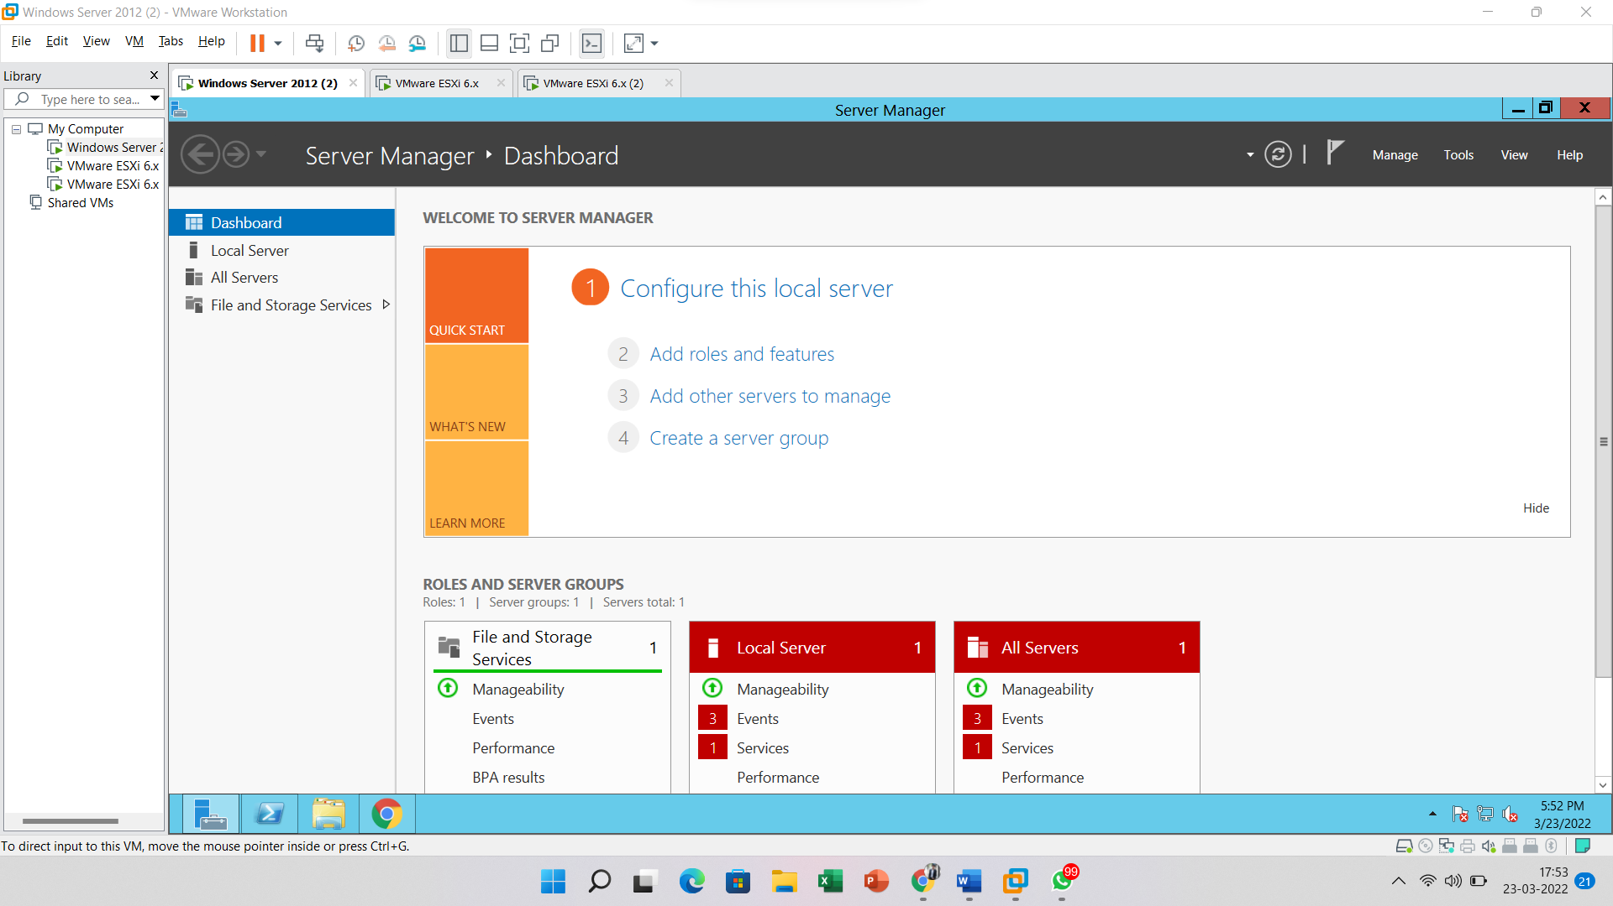

After clicking the below screen appear then Click on the **Next** button

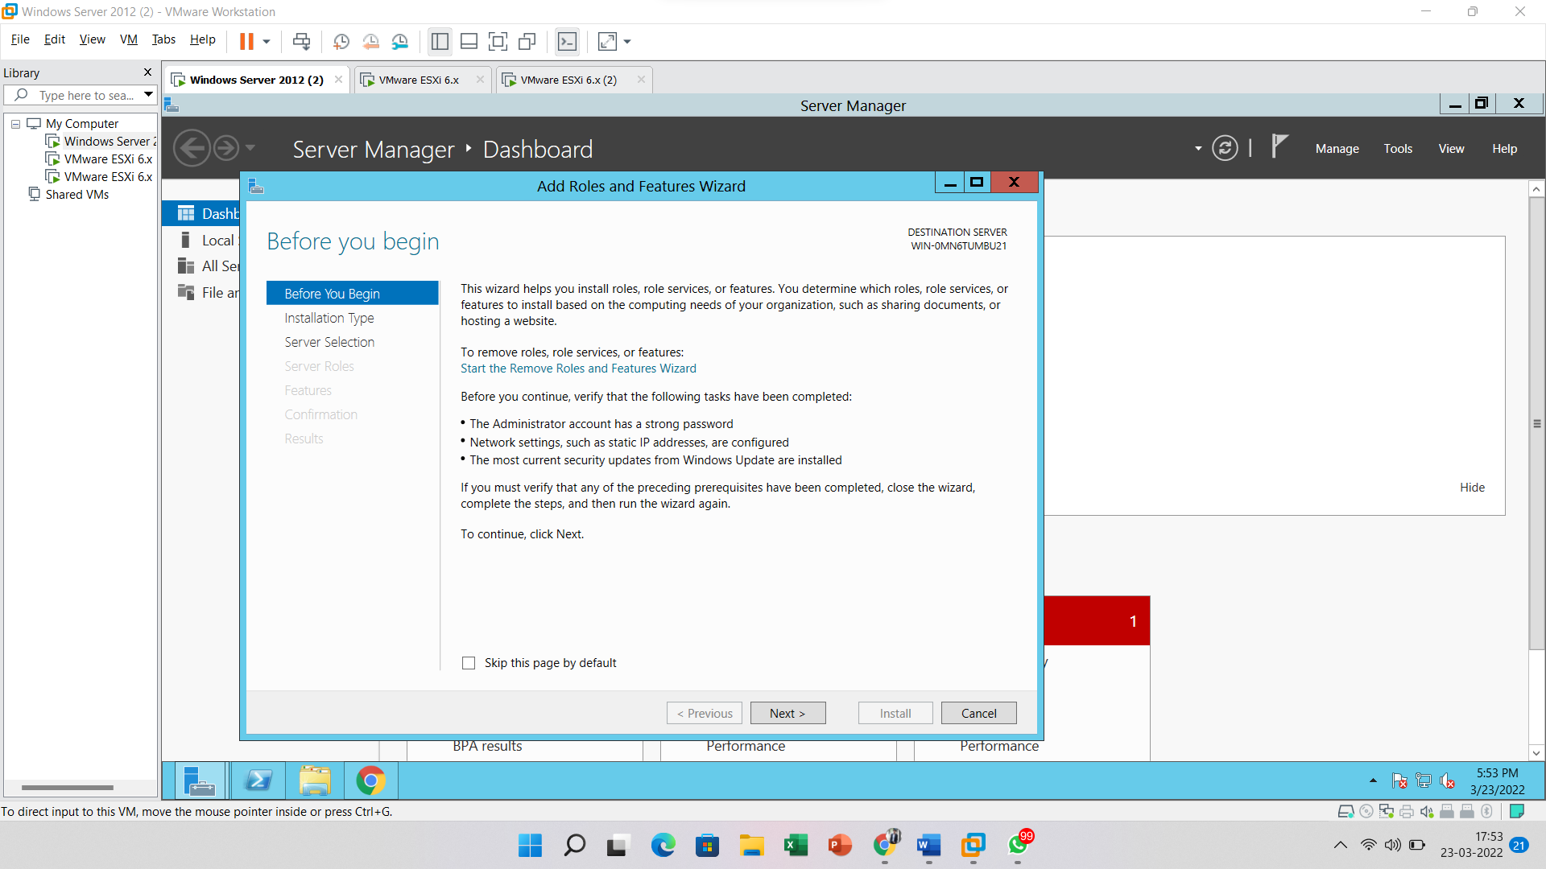

Select the **Role-based** installation and Click on the **Next** button

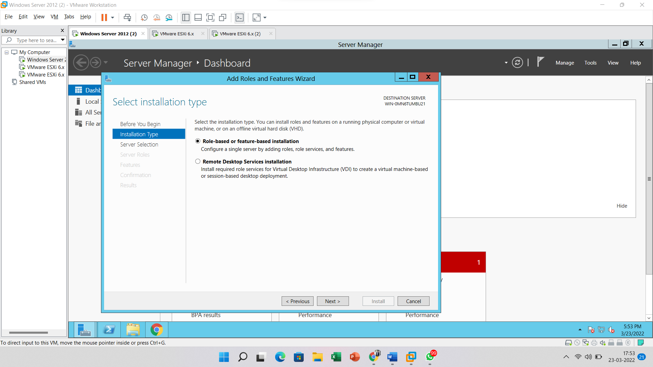

Click on the **Next** button

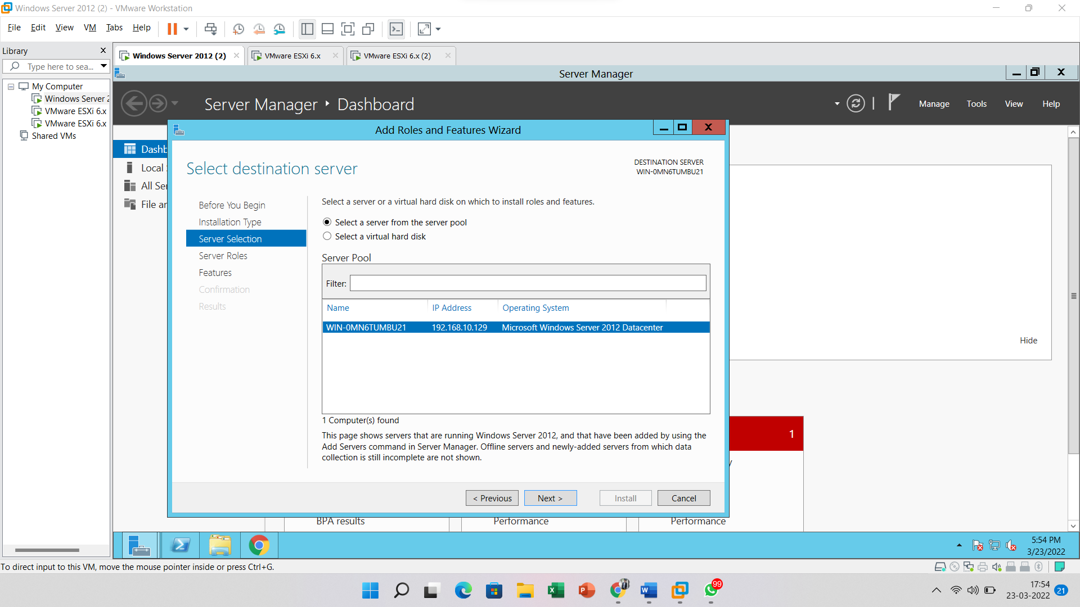

After that go to the roles and look for **File and iSCSI Services** and select **Server for NFS**.

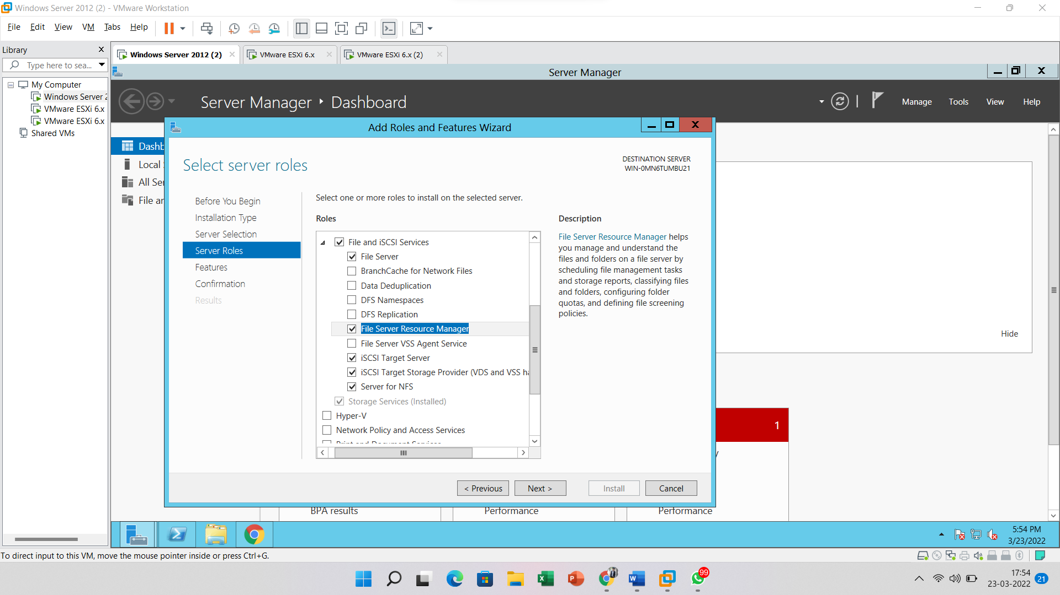

Click on the **Next** button

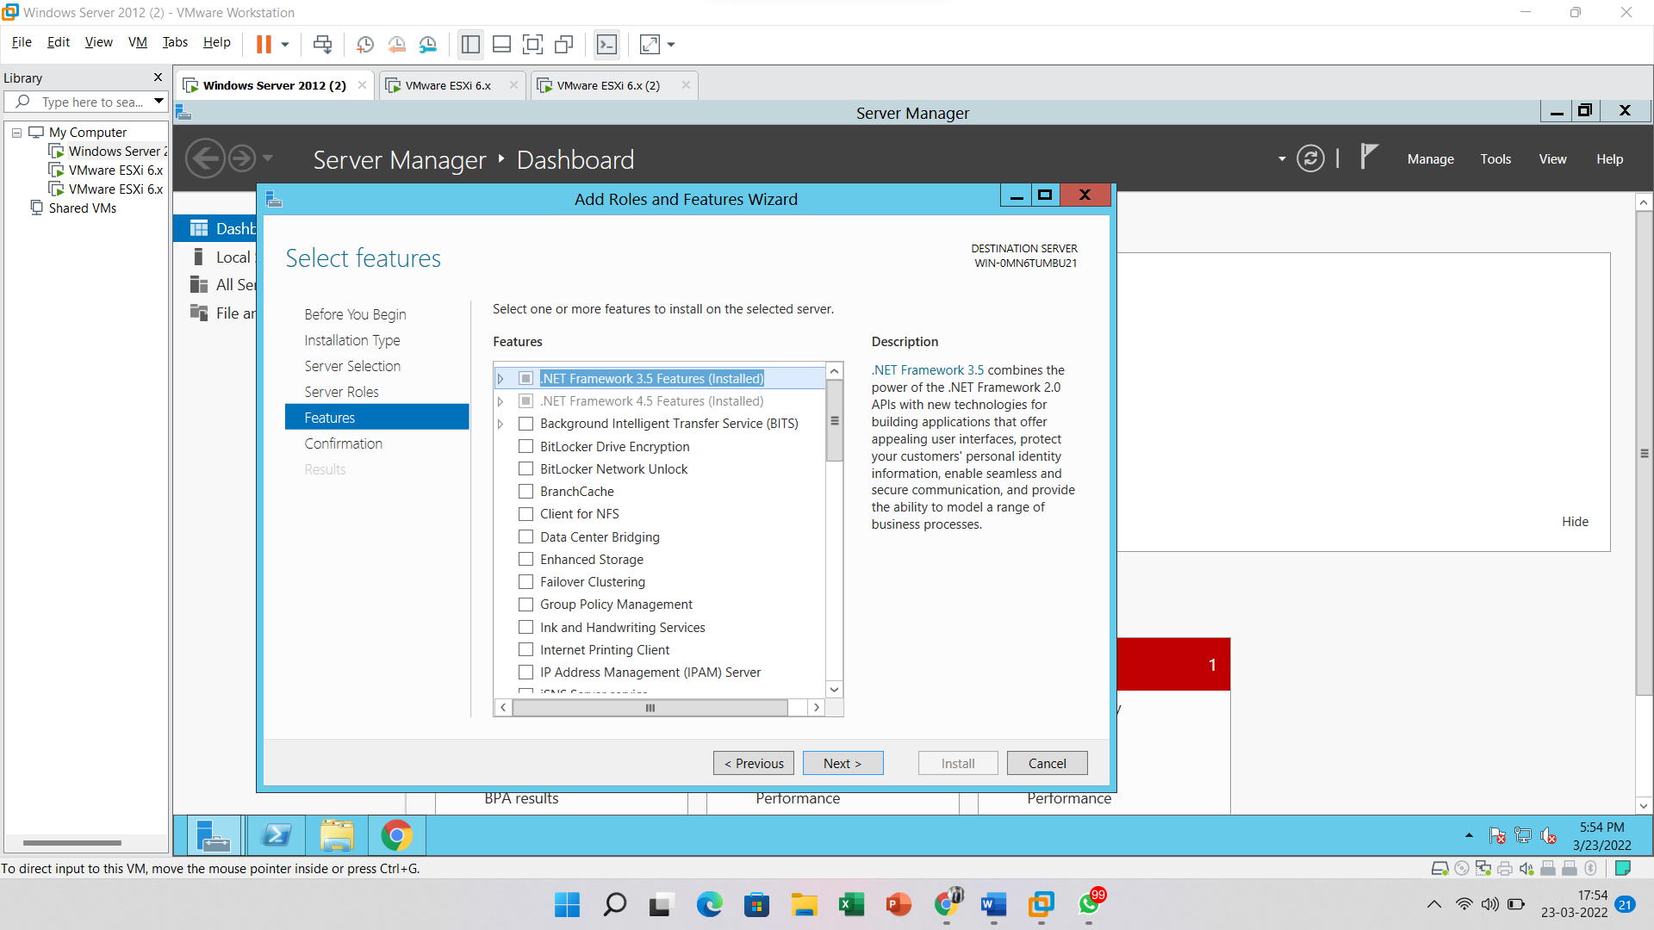

Click on the **Install** button

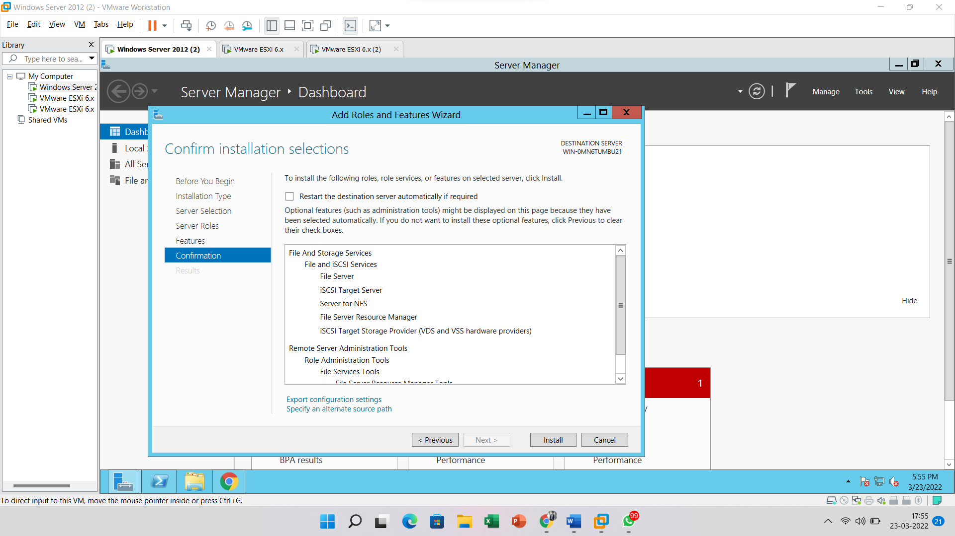

After clicking on the install button, the below screen will appear.

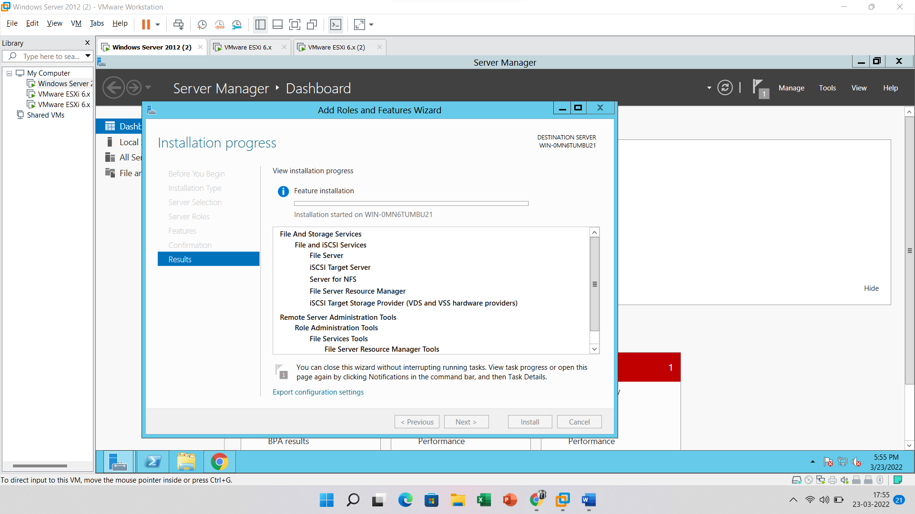

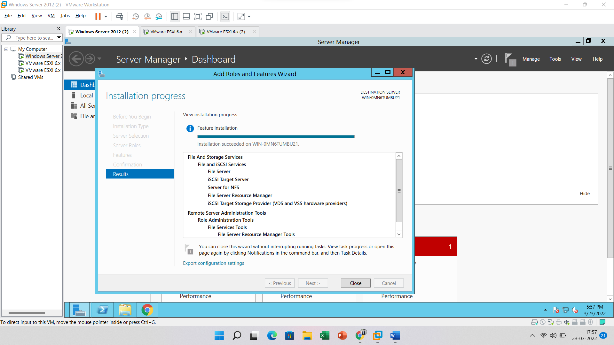

After adding the role of iSCSI go to the below path **Server Manager > File and Storage Services > iSCSI**

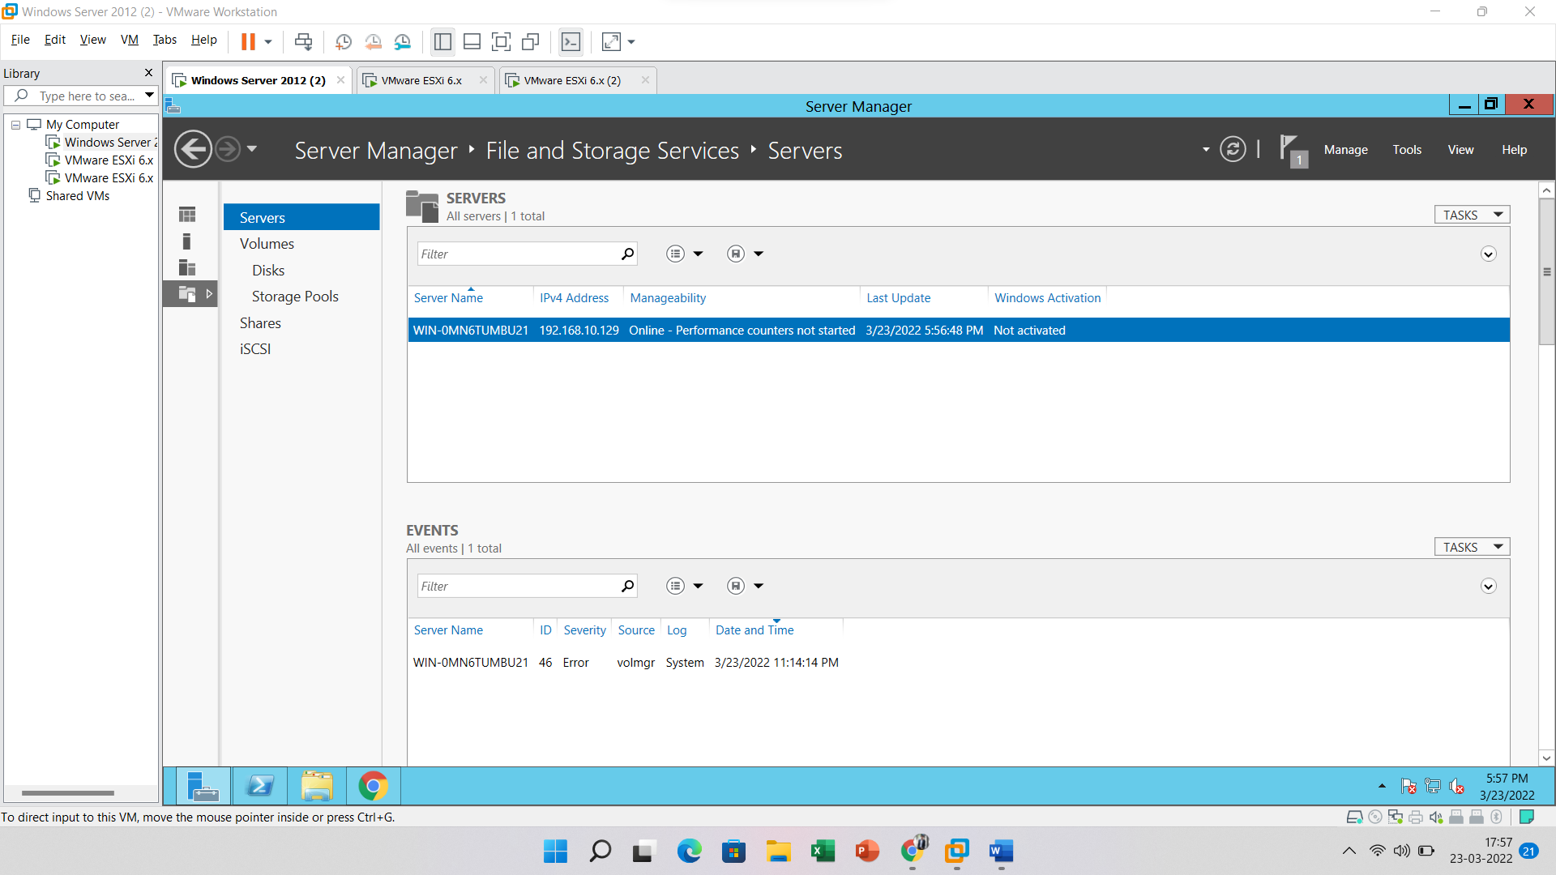

Create an **iSCSI** Virtual Disk.

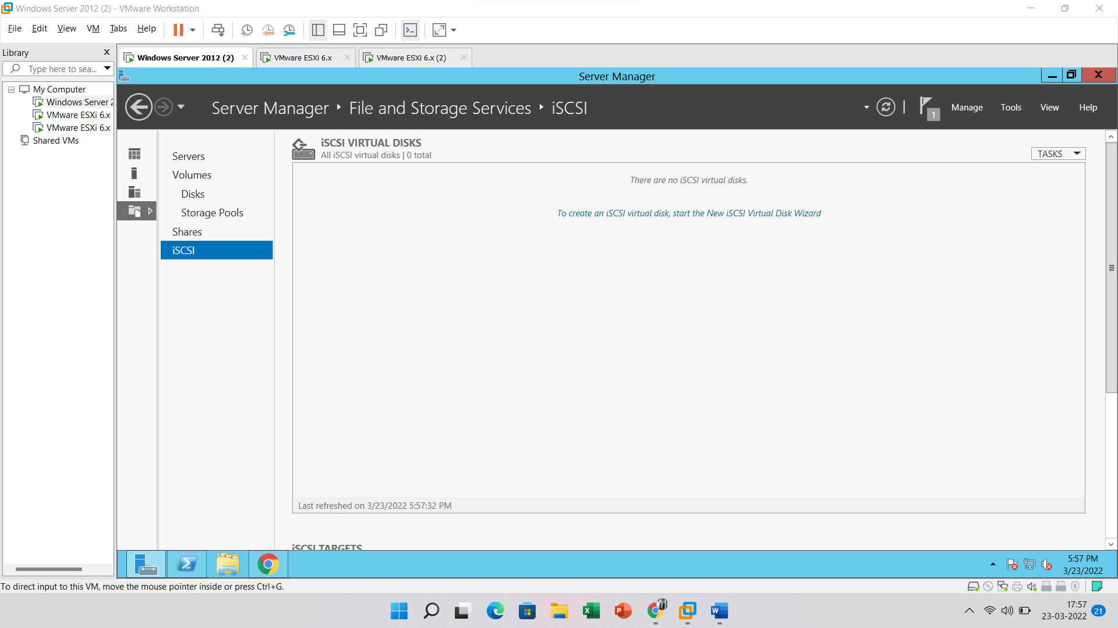

Just click on the “**To create an iSCSI virtual disk, start the New Virtual Disk Wizard**” button.



After that below screen will appear and Click on the **Next** button

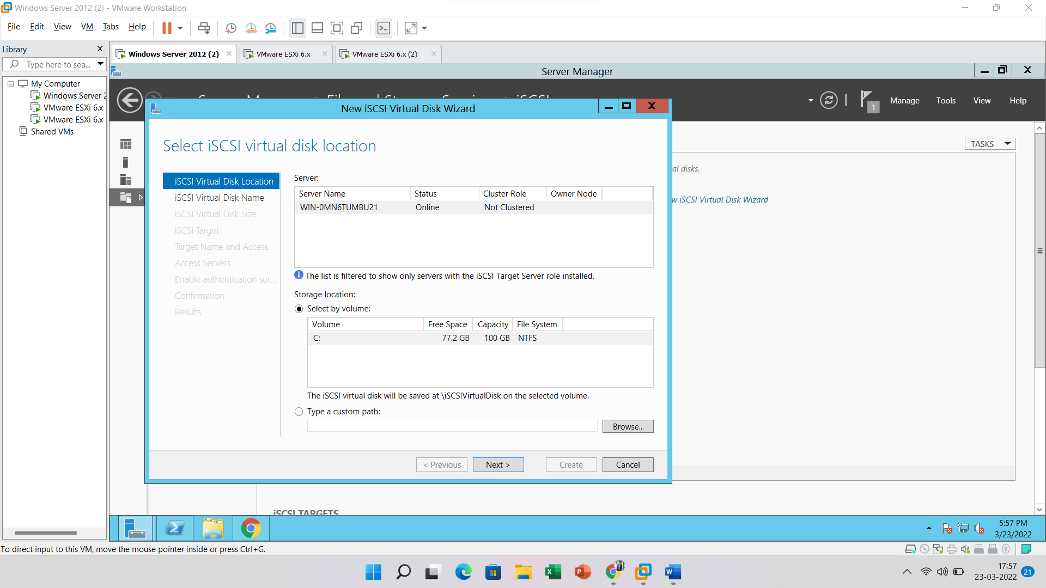

Enter **iSCSI virtual disk name** and click on the “**Next**” button

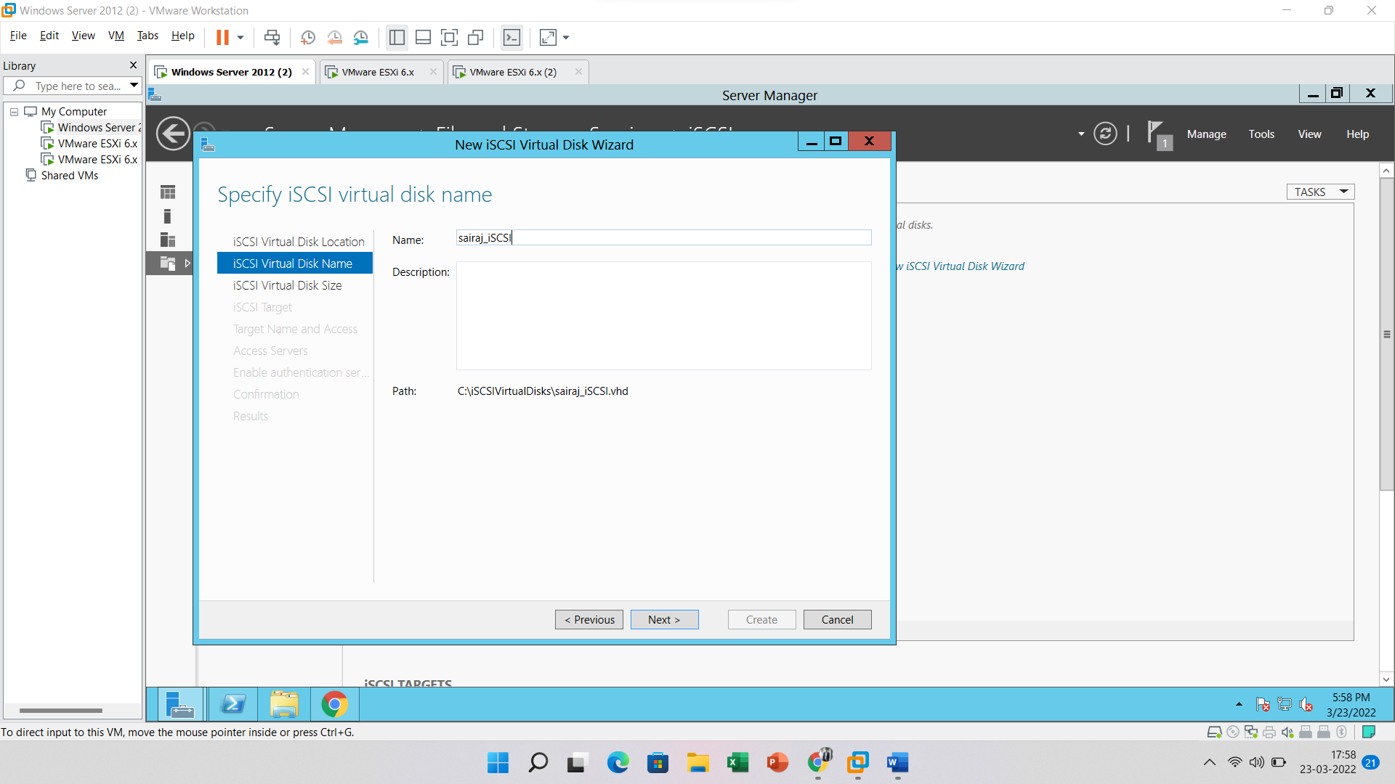

Enter **iSCSI virtual disk size** and click on the “**Next**” button.

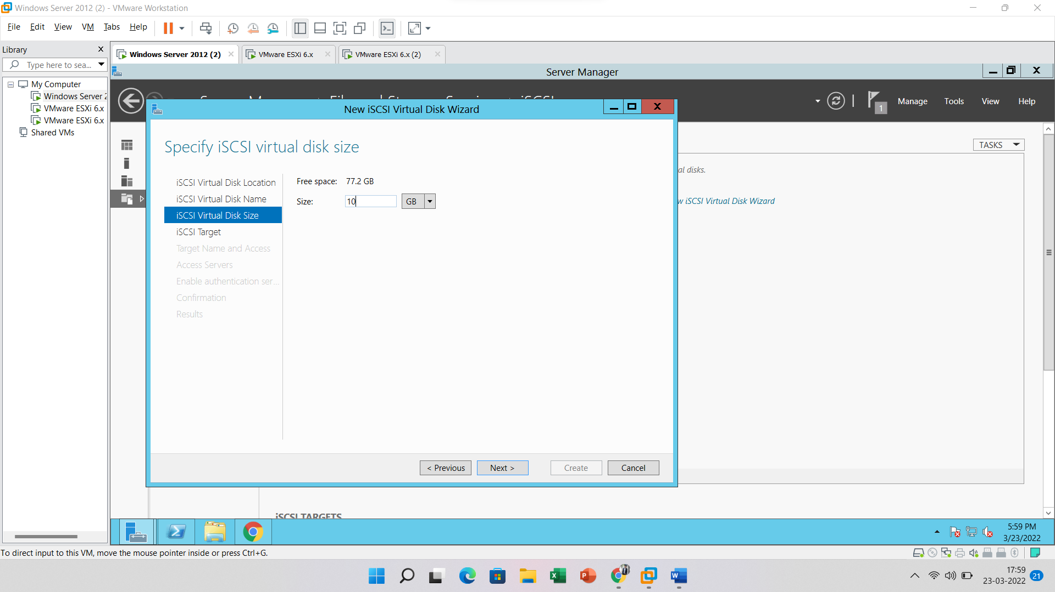

Choose the option “**New iSCSI target**” and click on the “**Next**” button.

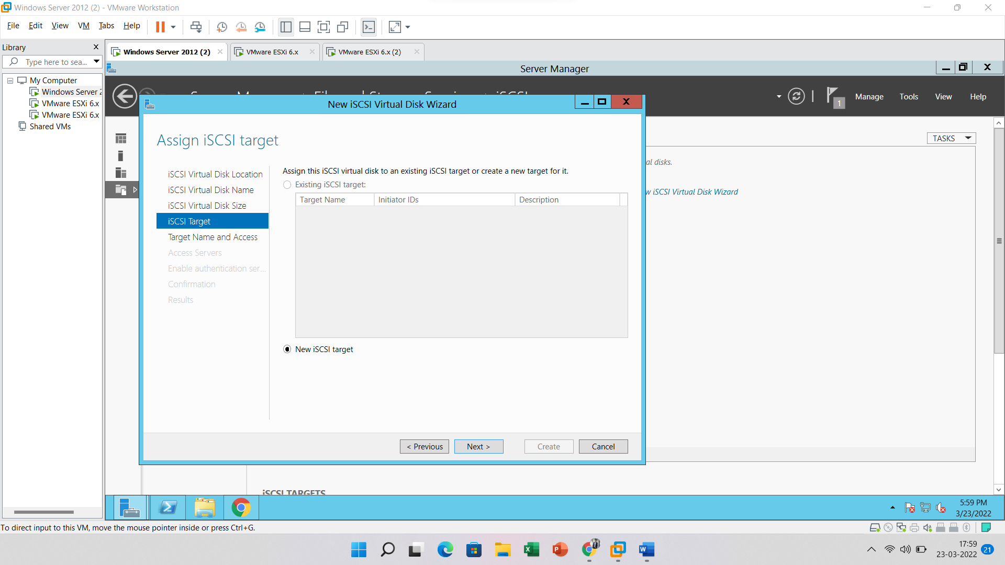

**Enter target name** and click “**Next**” button to proceed

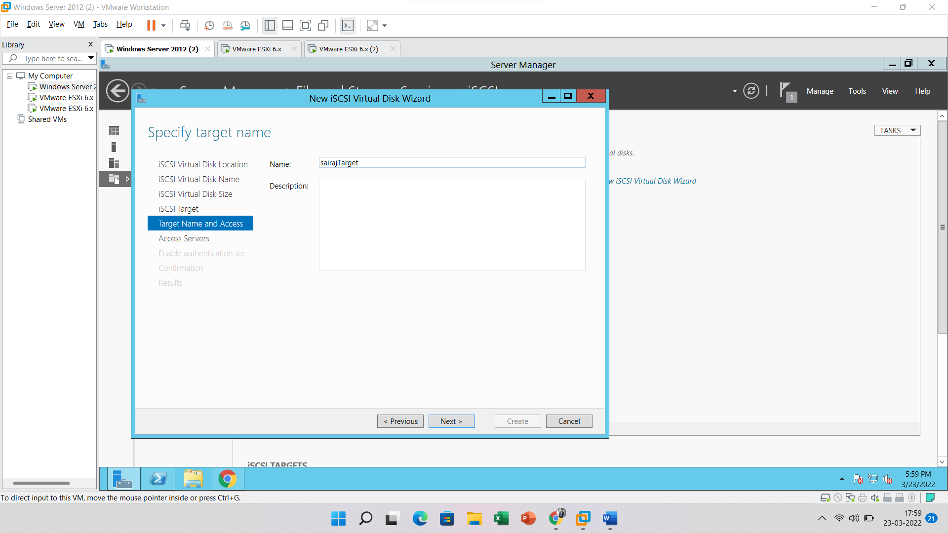

Here we need to specify which host can access this iSCSI virtual disk for this enter below details

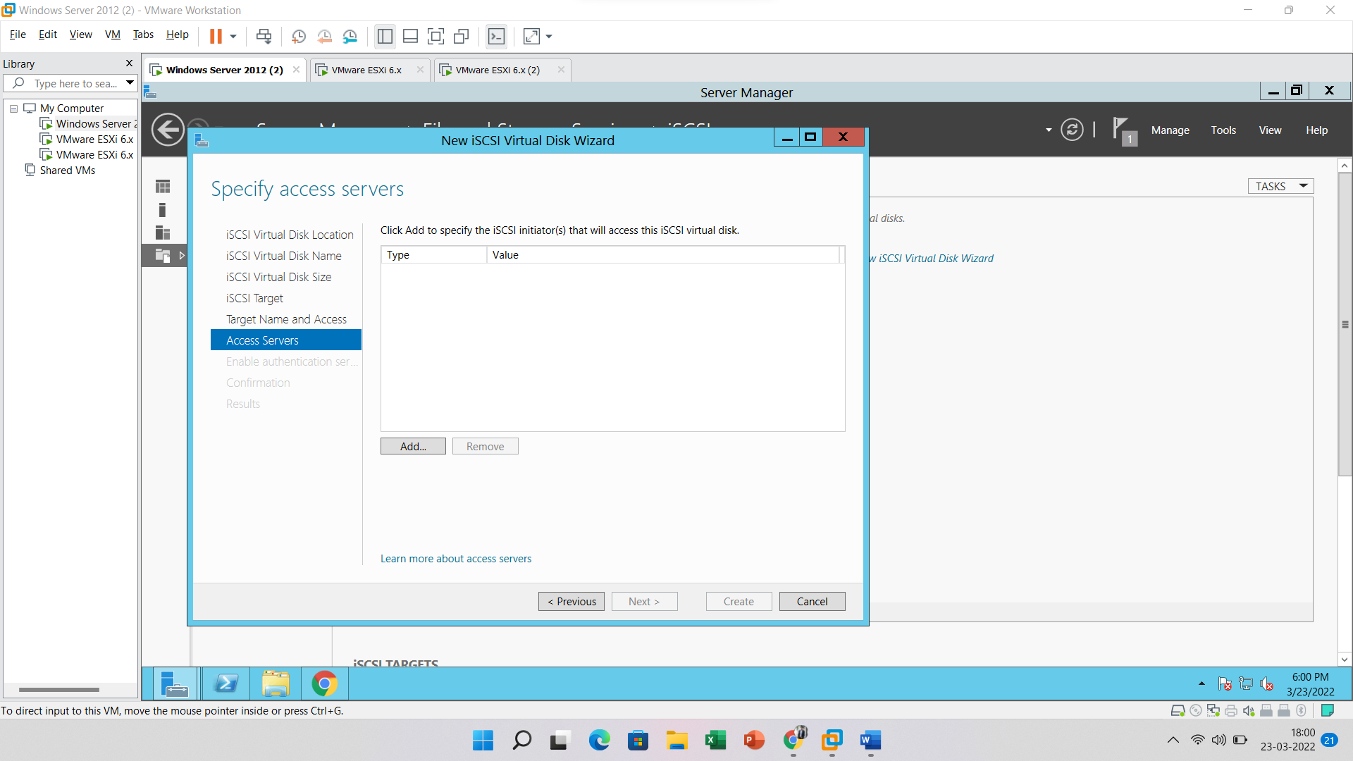

Choose the option “Enter a value for the selected type” and write below details

Type: Choose an option (IP Address)

Value: Enter IP address of Host

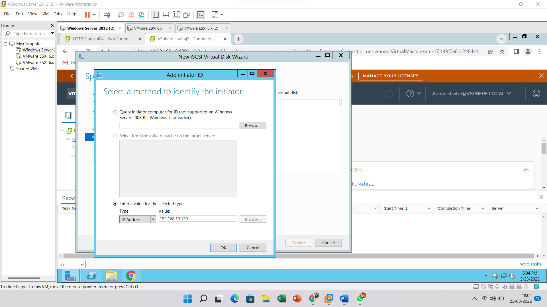

Click on the **Next** button

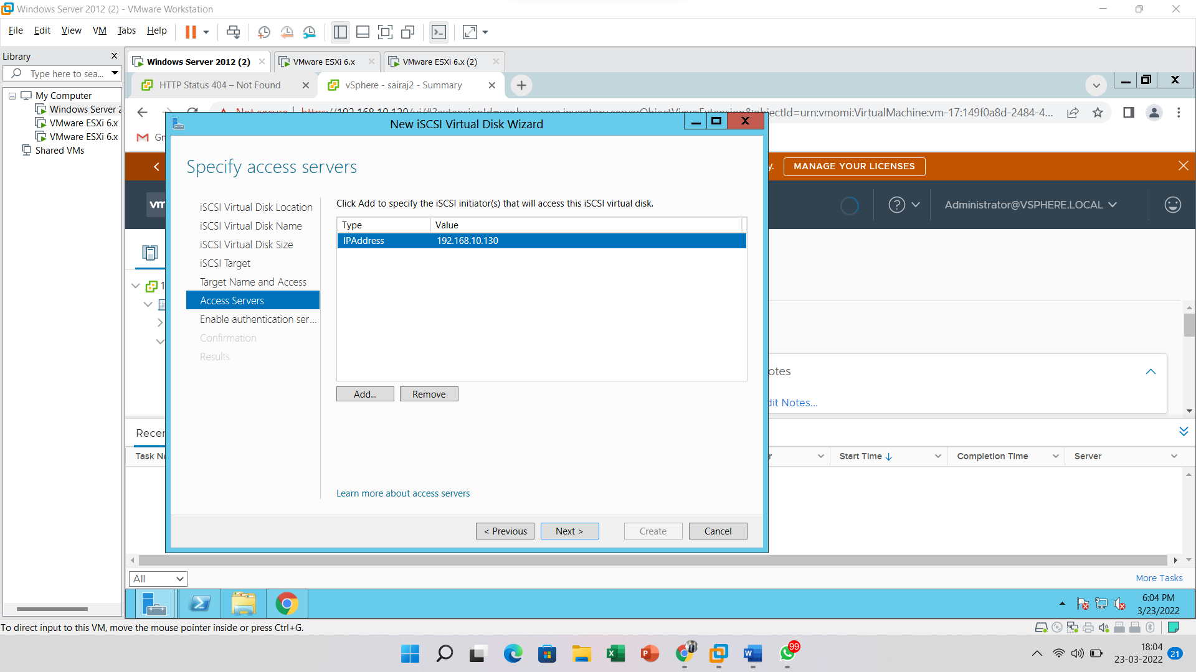

Click on the **Next** button

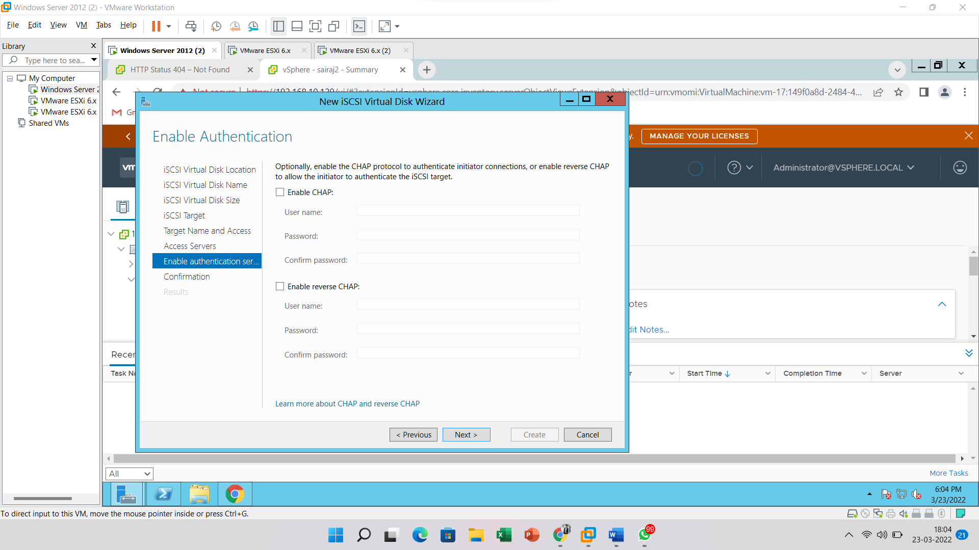

Click on the **Create** button

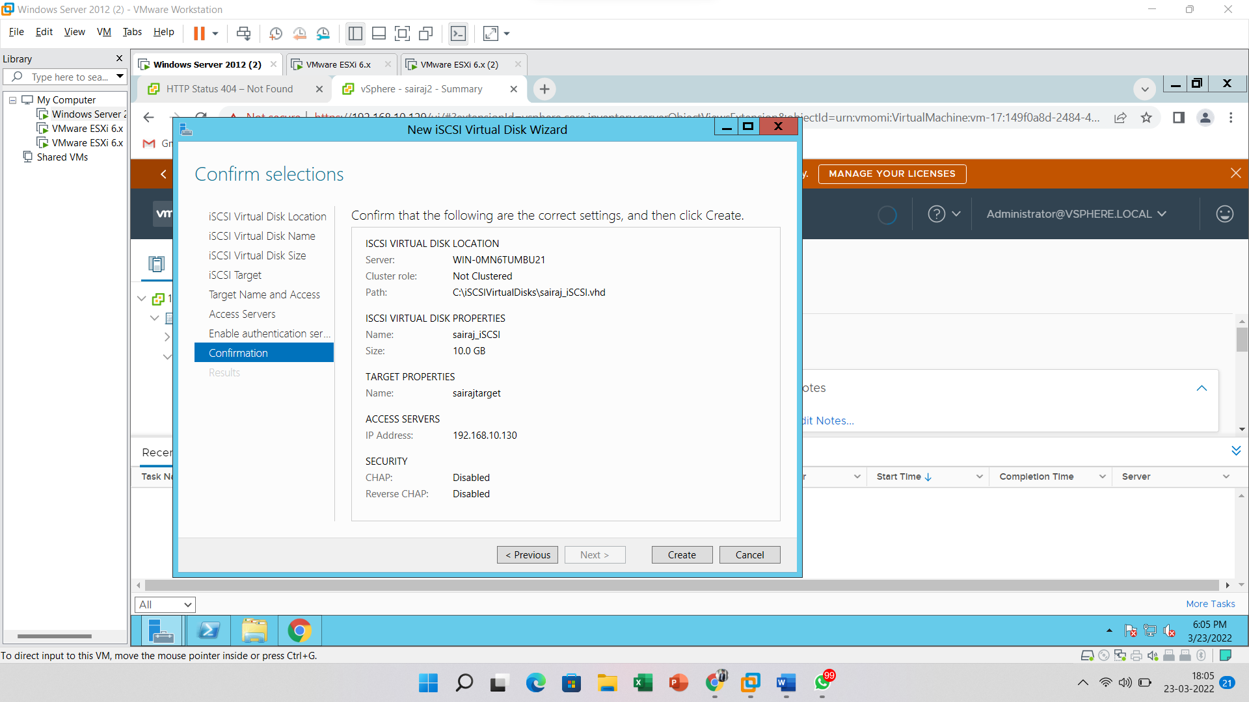

Here you can see iSCSI disk has been created successfully

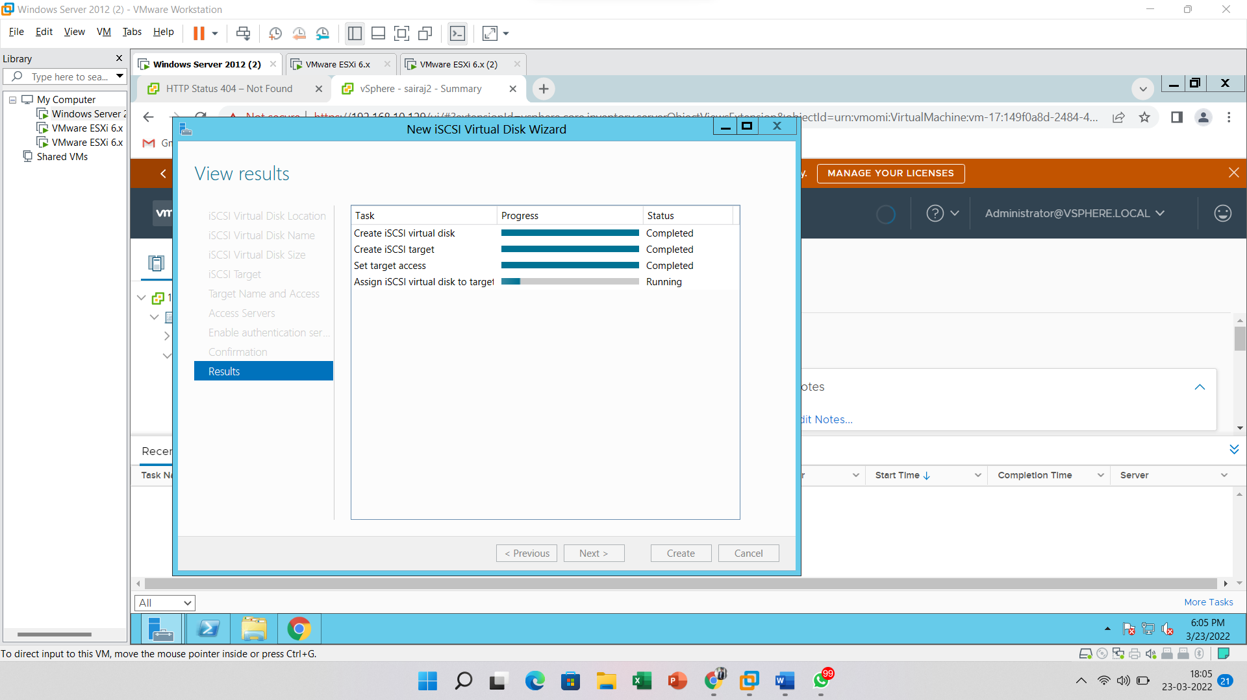

Create an iSCSI Adapter and configure an iSCSI adapter with the server

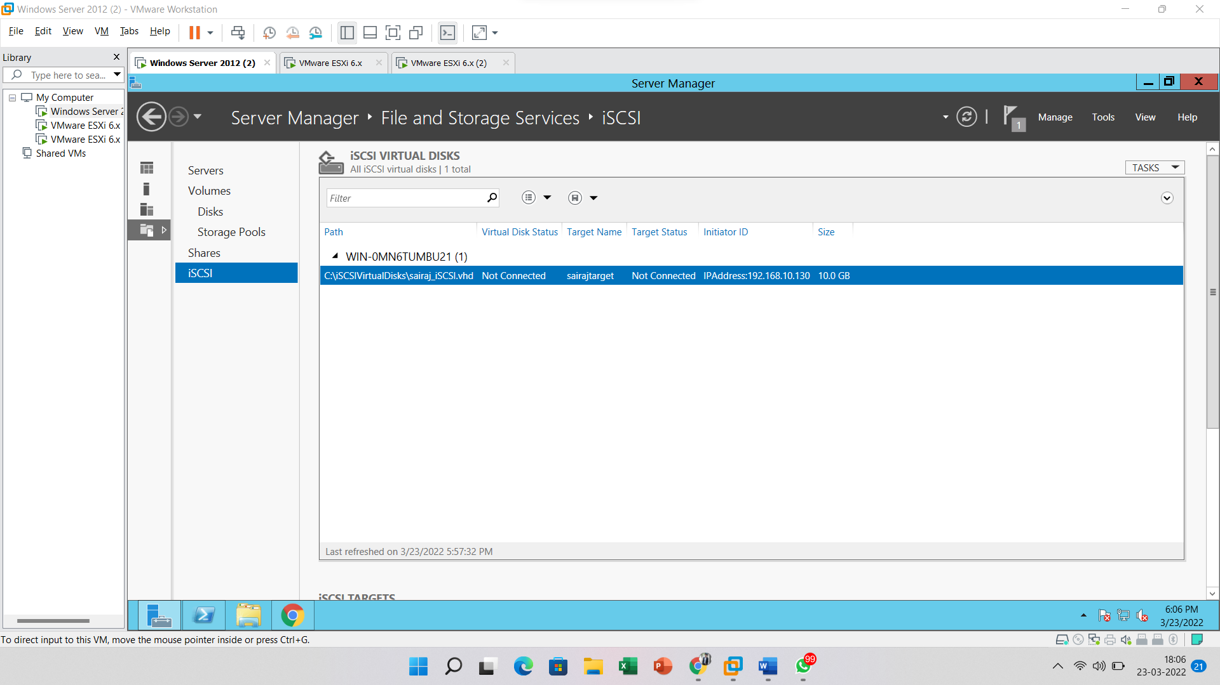

Create an iSCSI Adapter and configure an iSCSI adapter with the server

Login into vSphere client and go to the **Configuration tab** of the **host** where you want to add an iSCSI virtual disk.

Now go to “**Storage Adapters**” then choose “**Add Software Adapter**”

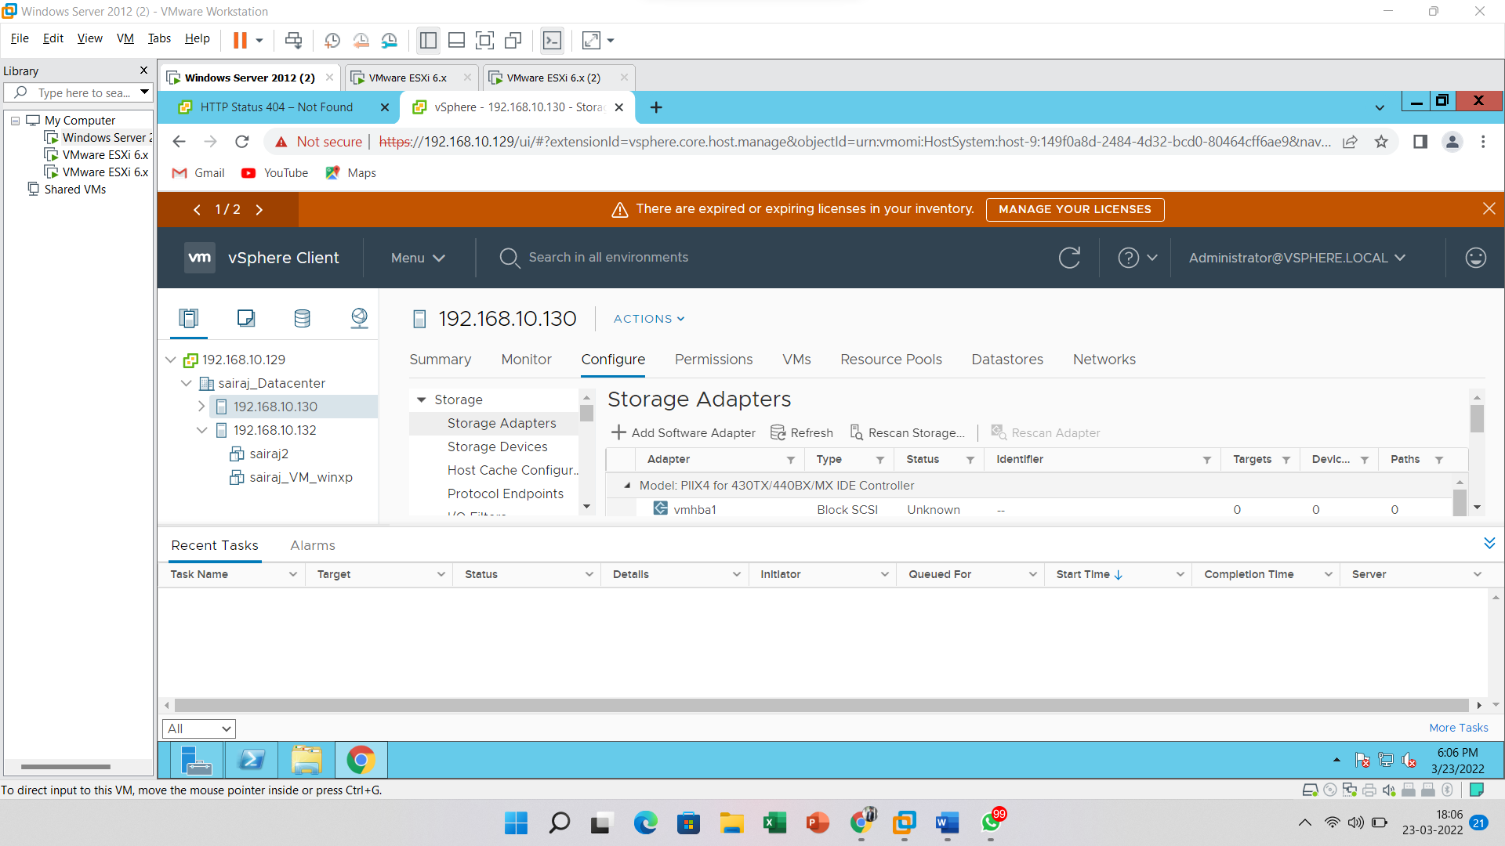

Showing the above popup then first **refresh** the entire link

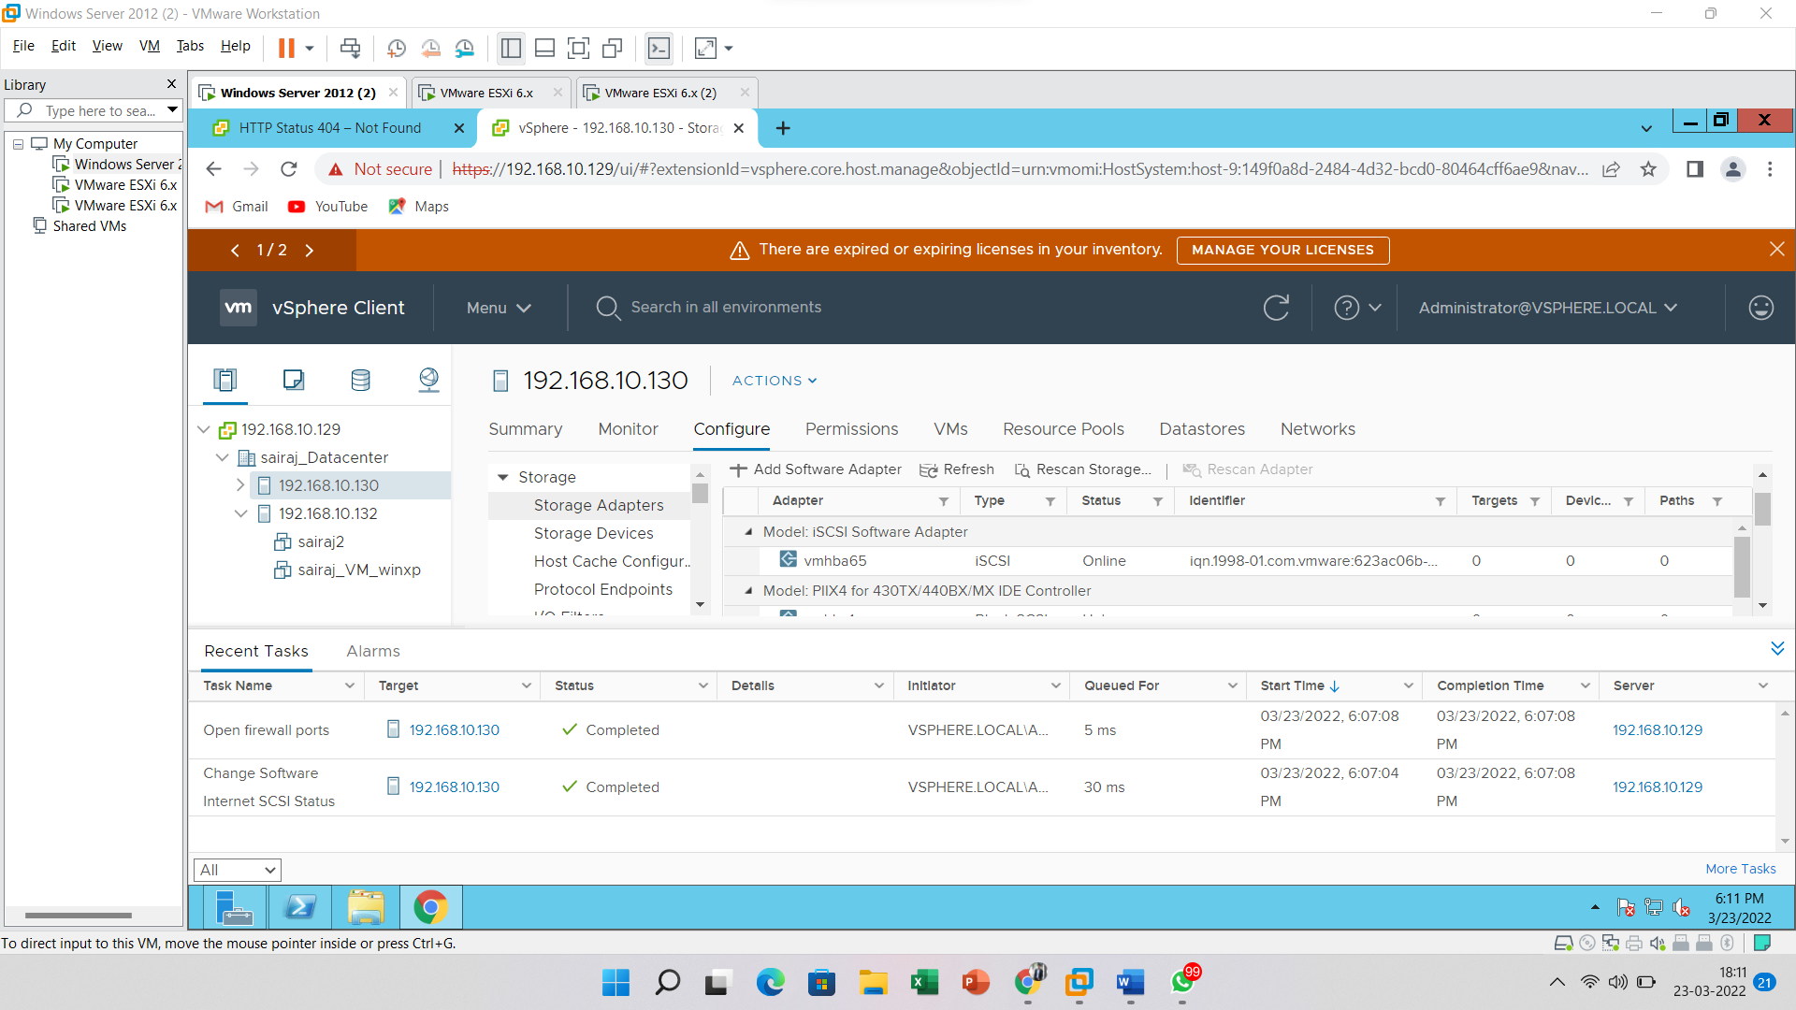

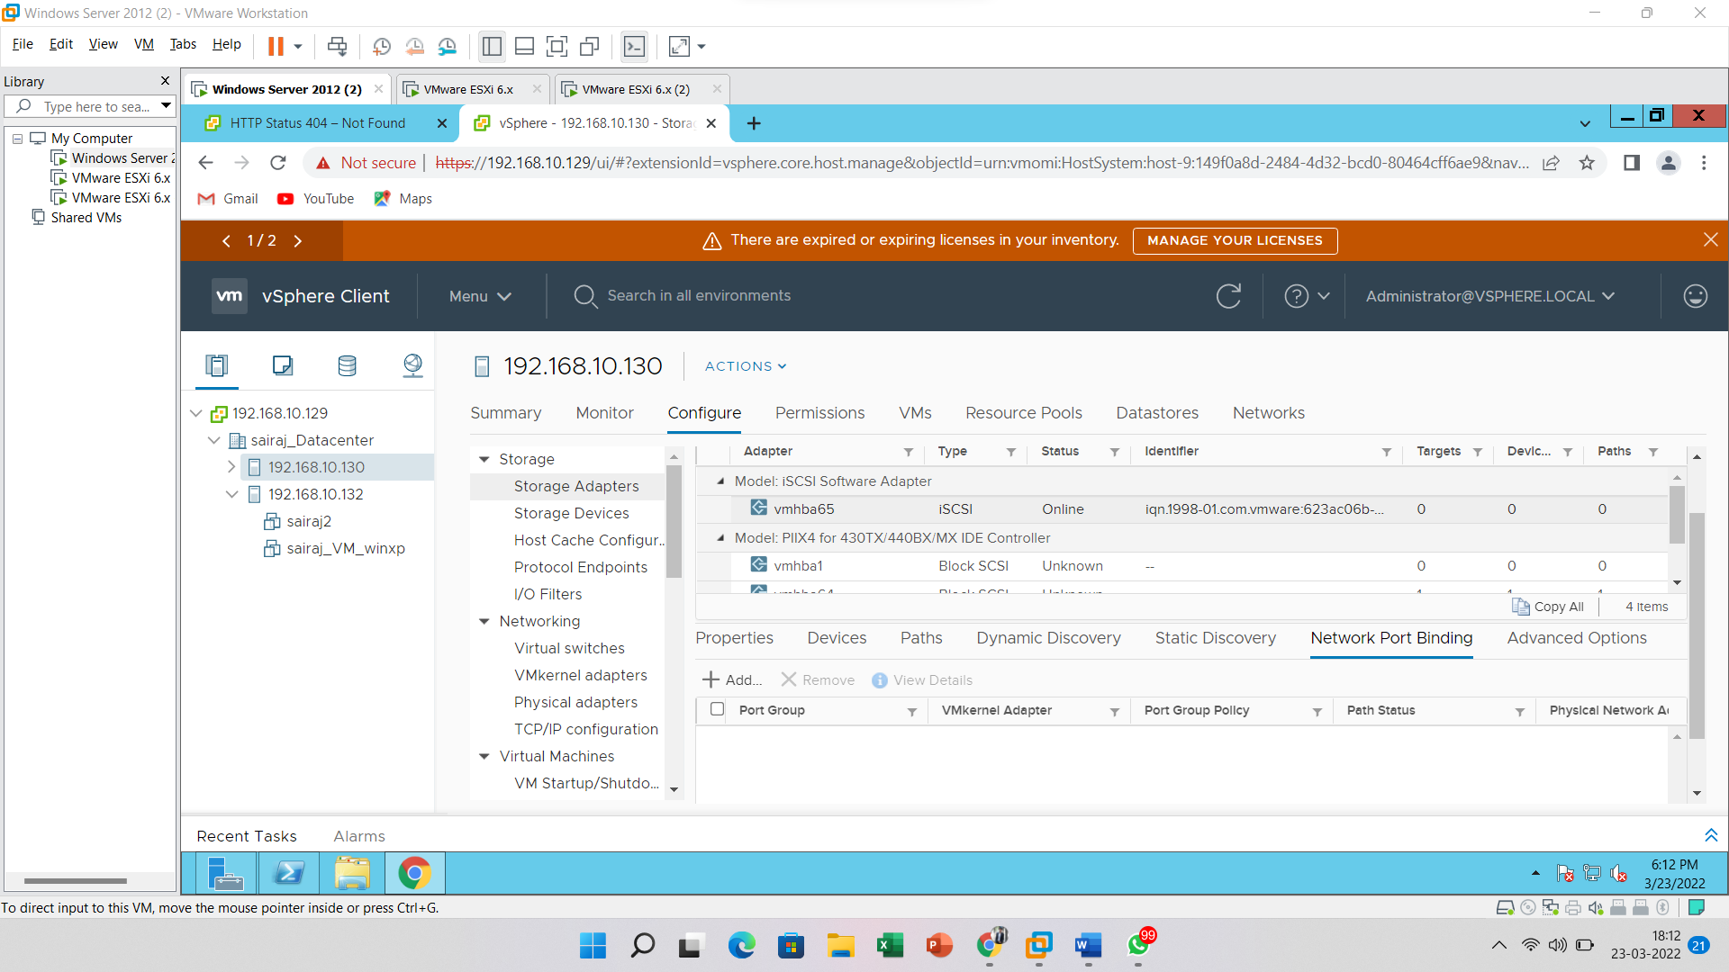

Select the **Add Software iSCSI Adapter** and click on the **OK** button

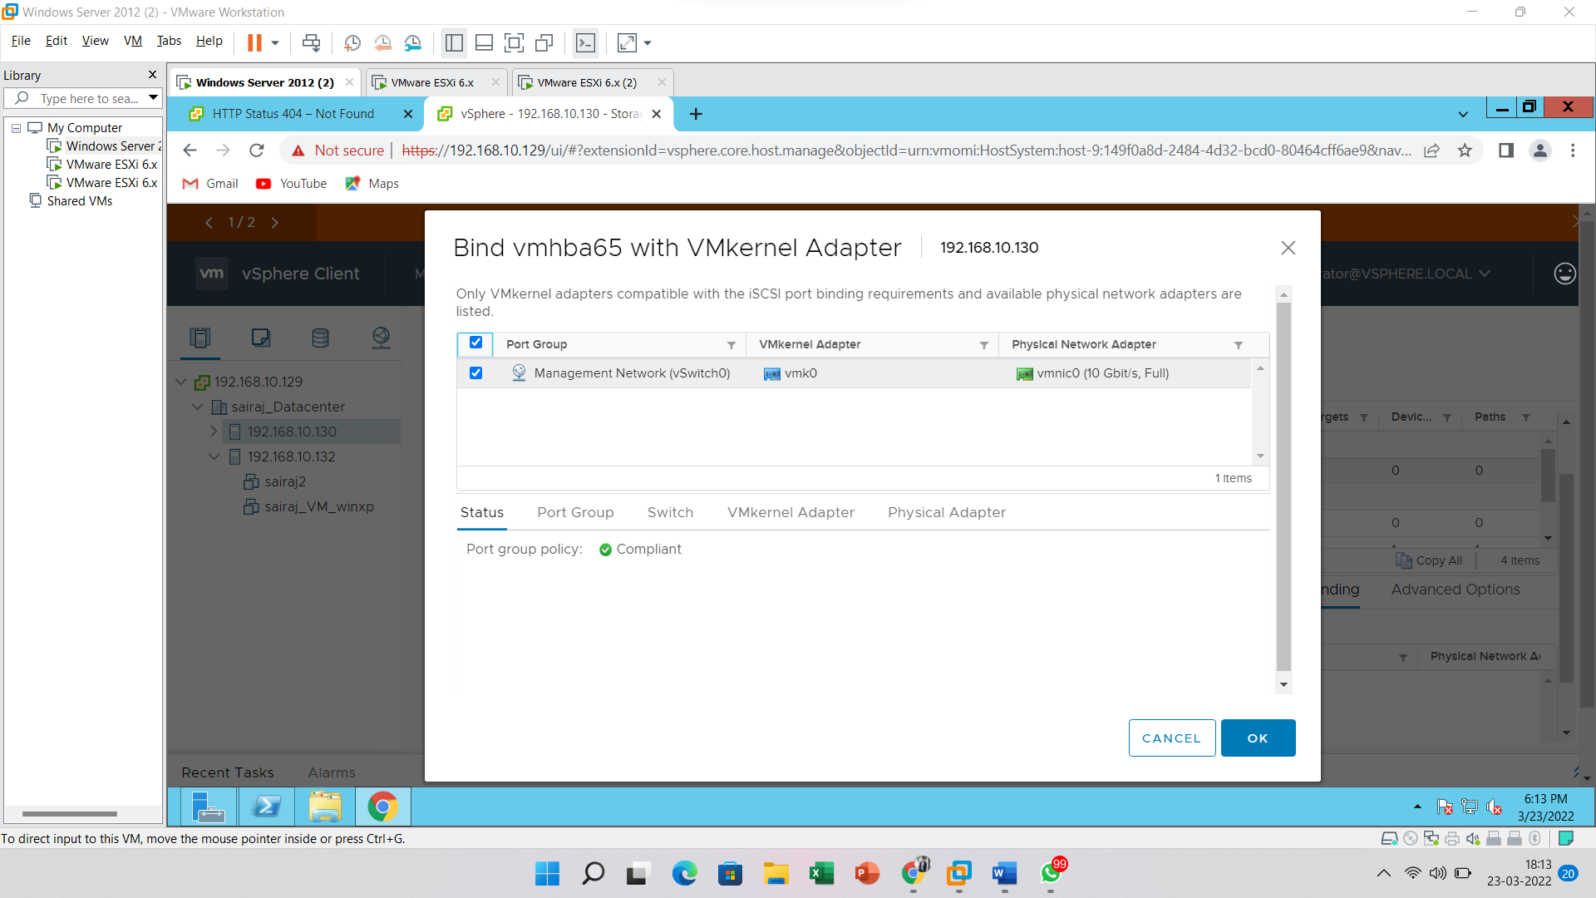

After Click on **OK** then refresh the Host and Here enable the **Rescan Adapter**

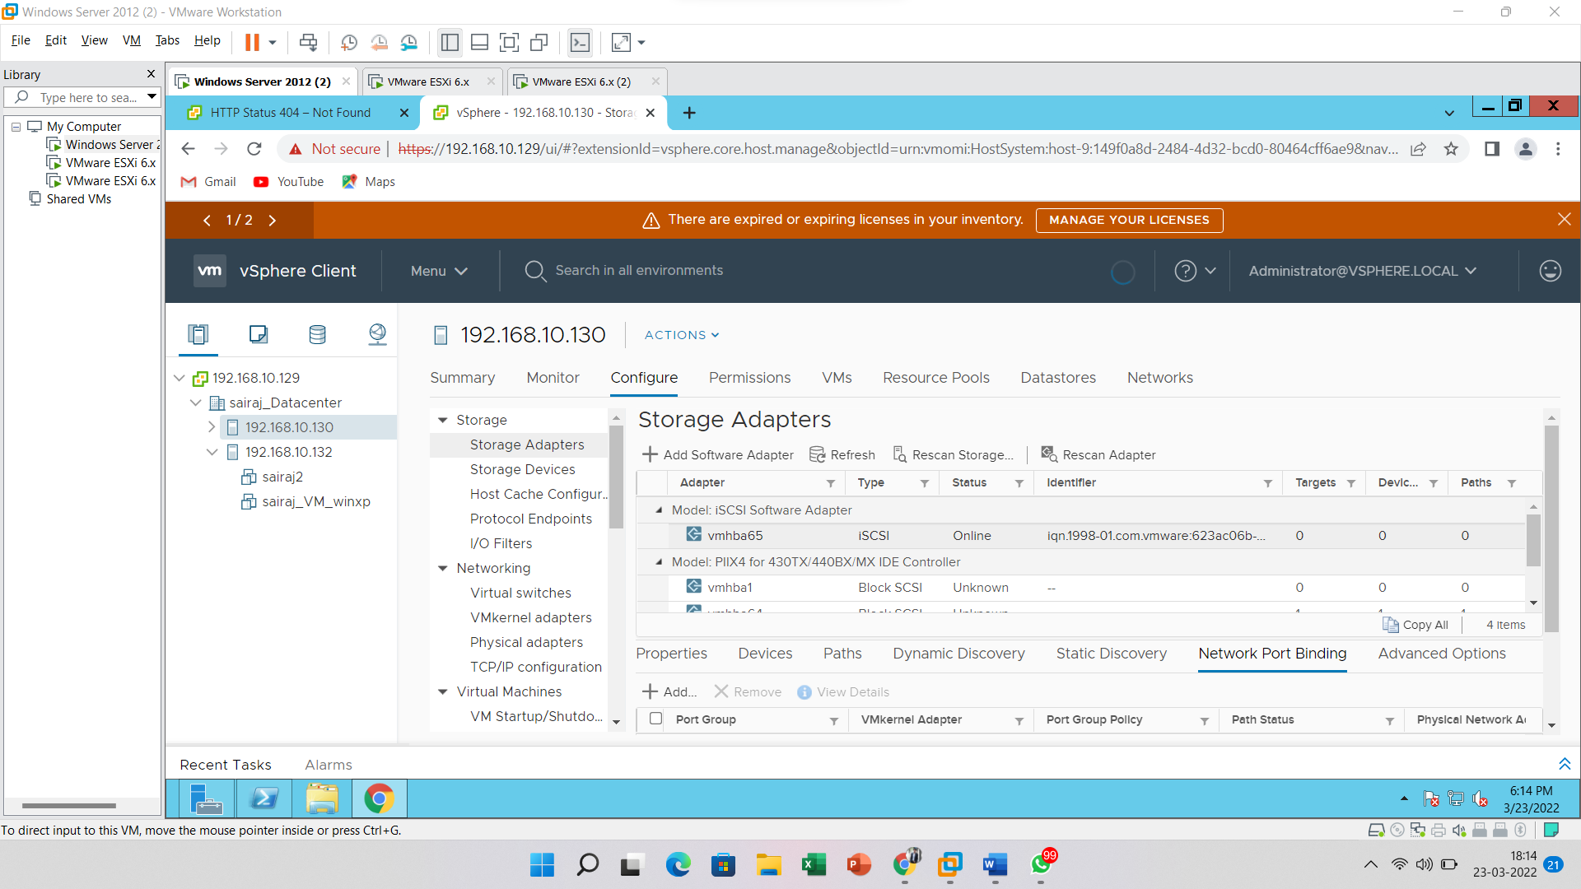

Enter the iSCSI Server details and Click on the **OK** button

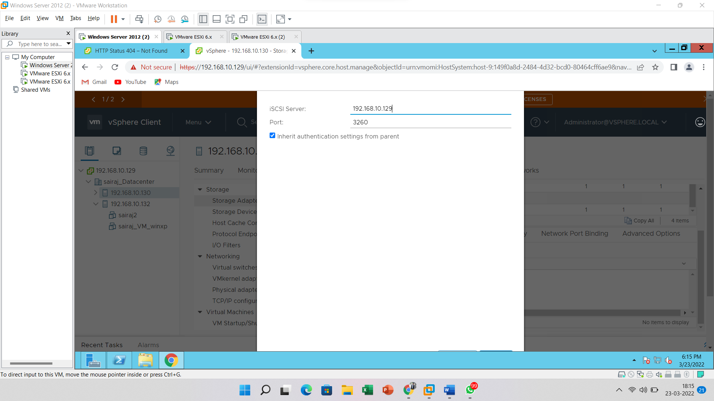

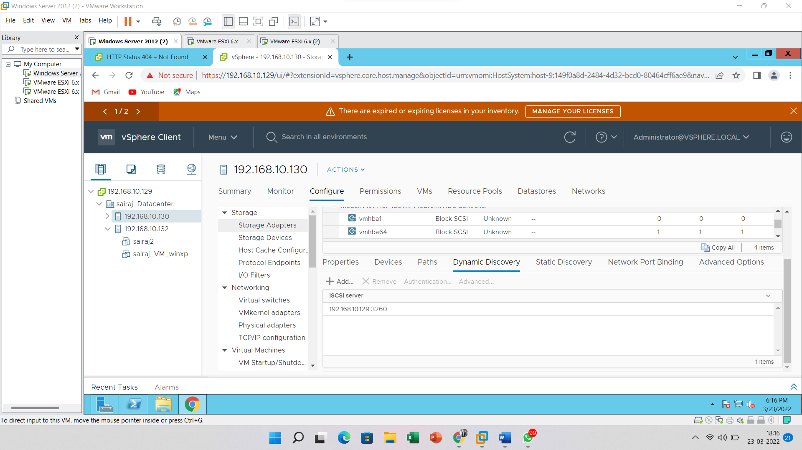

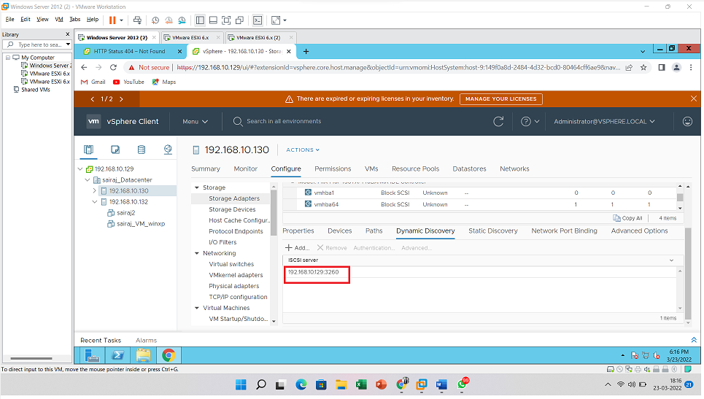

Create **iSCSI Storage** to Host. Right Click on Host > Storage > New Database

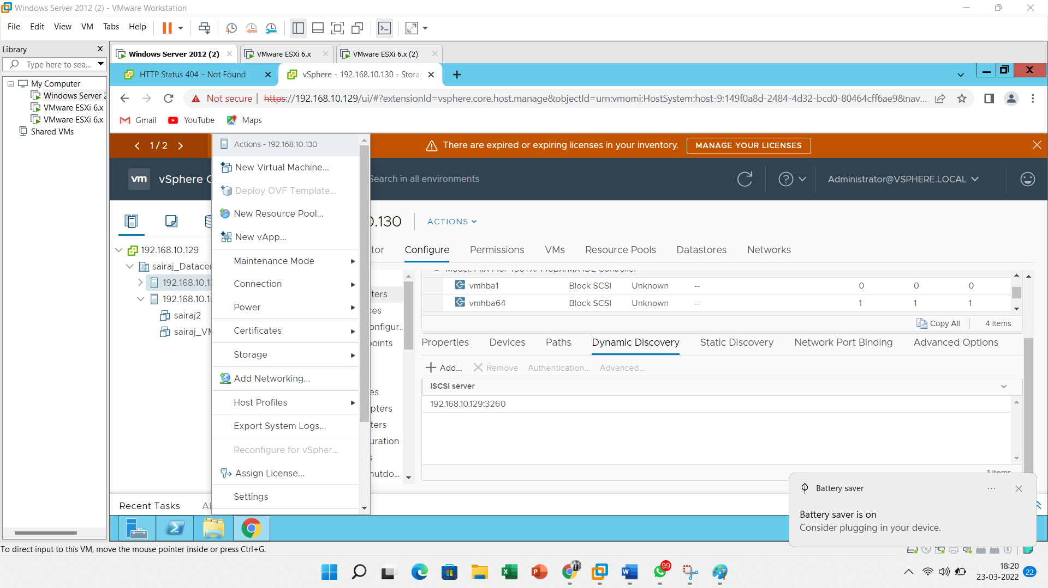

Select type as **VMFS**.

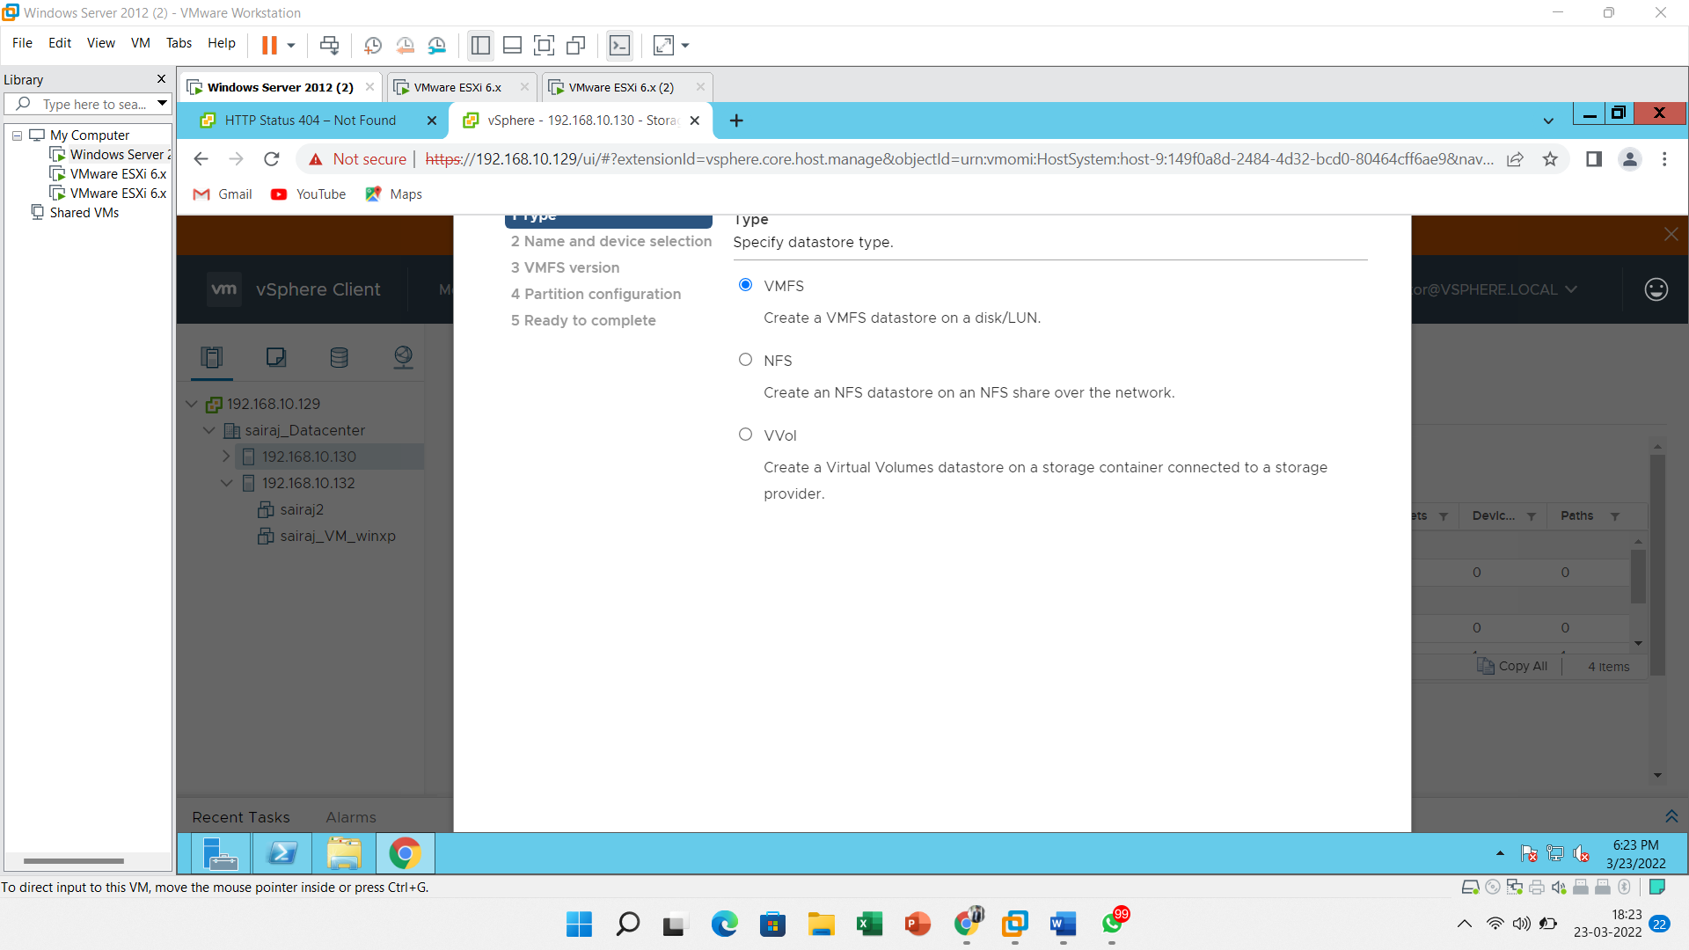

In Name and device selection, give the name to the datastore

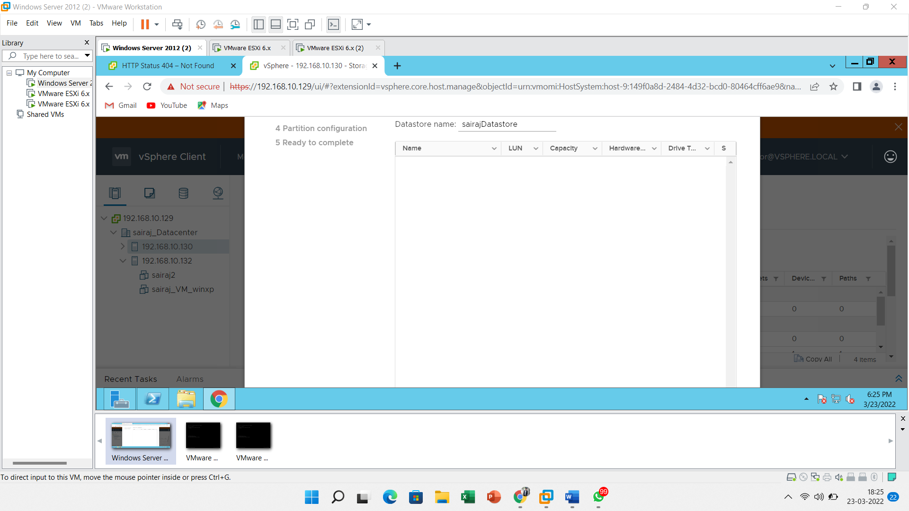

Select the **first option** in the **VMFS version** menu.

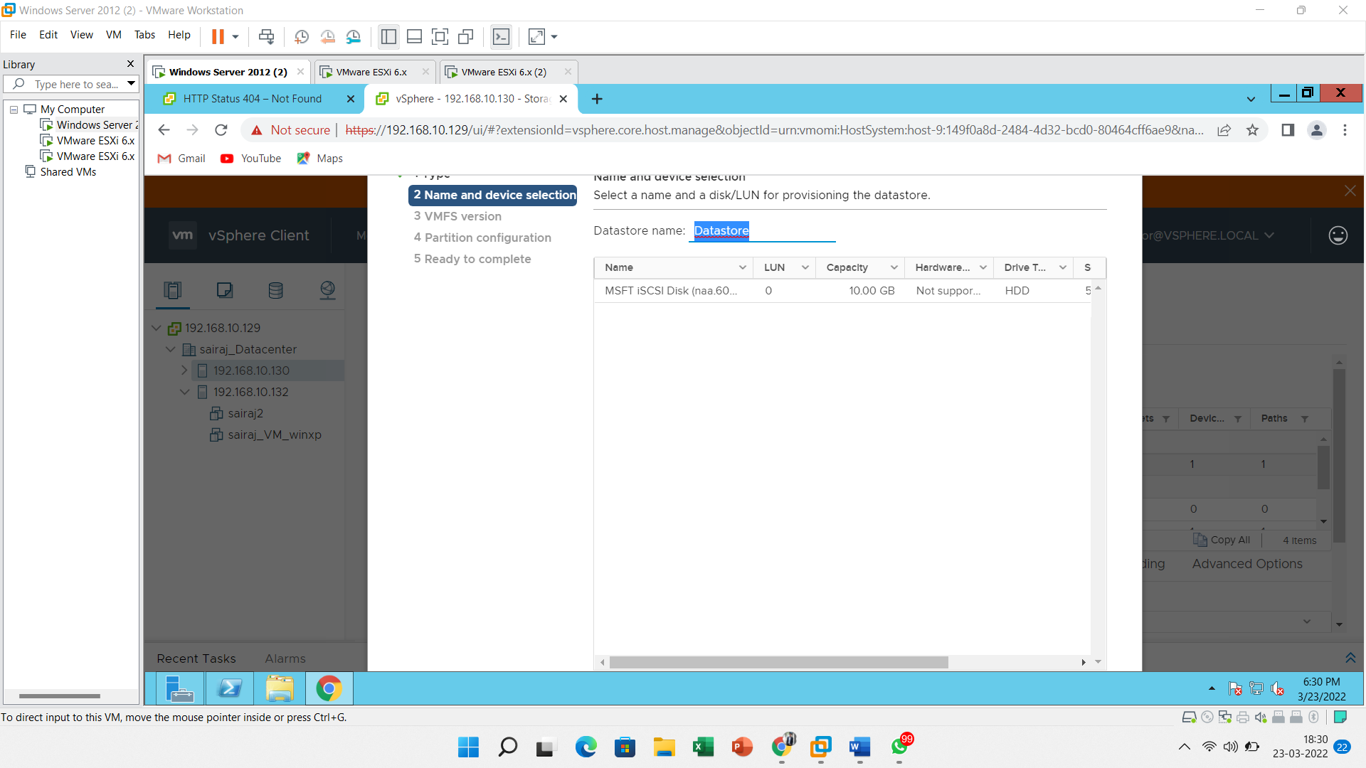

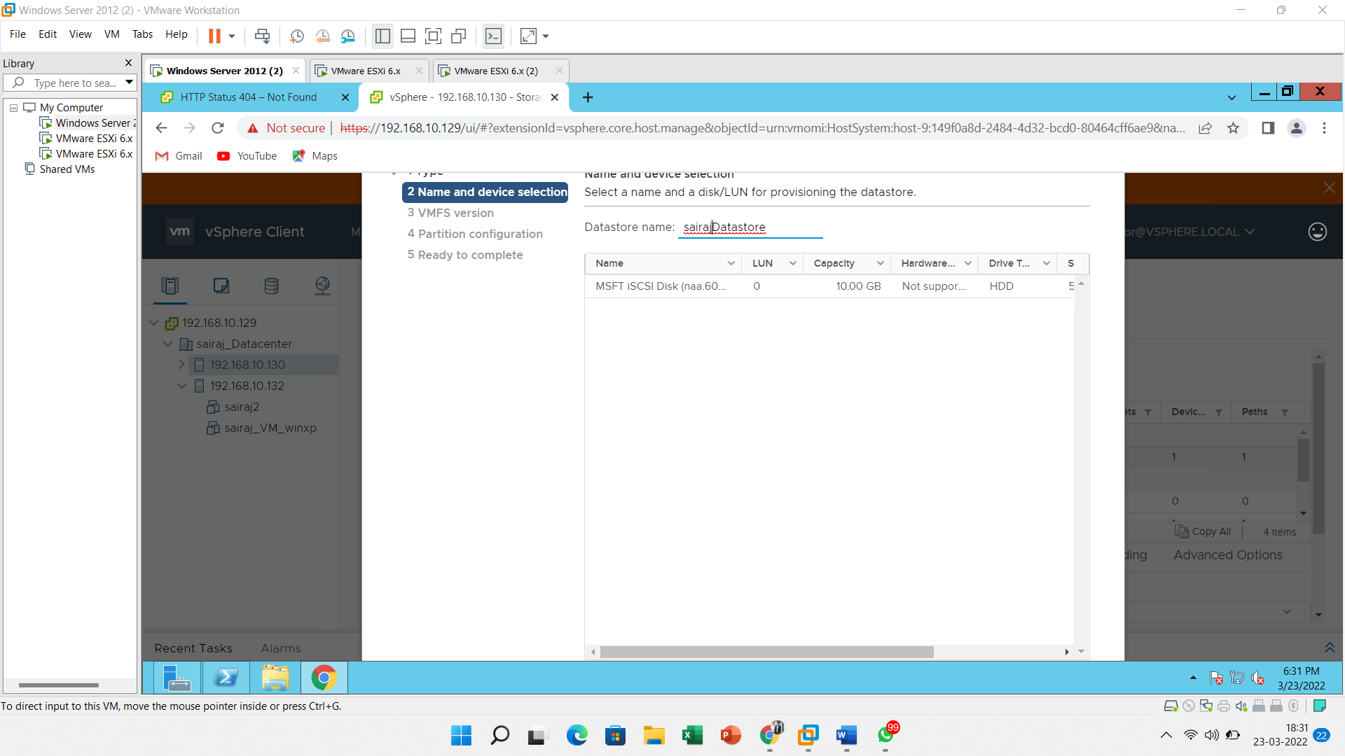

Select the **first option** in the **VMFS version** menu.

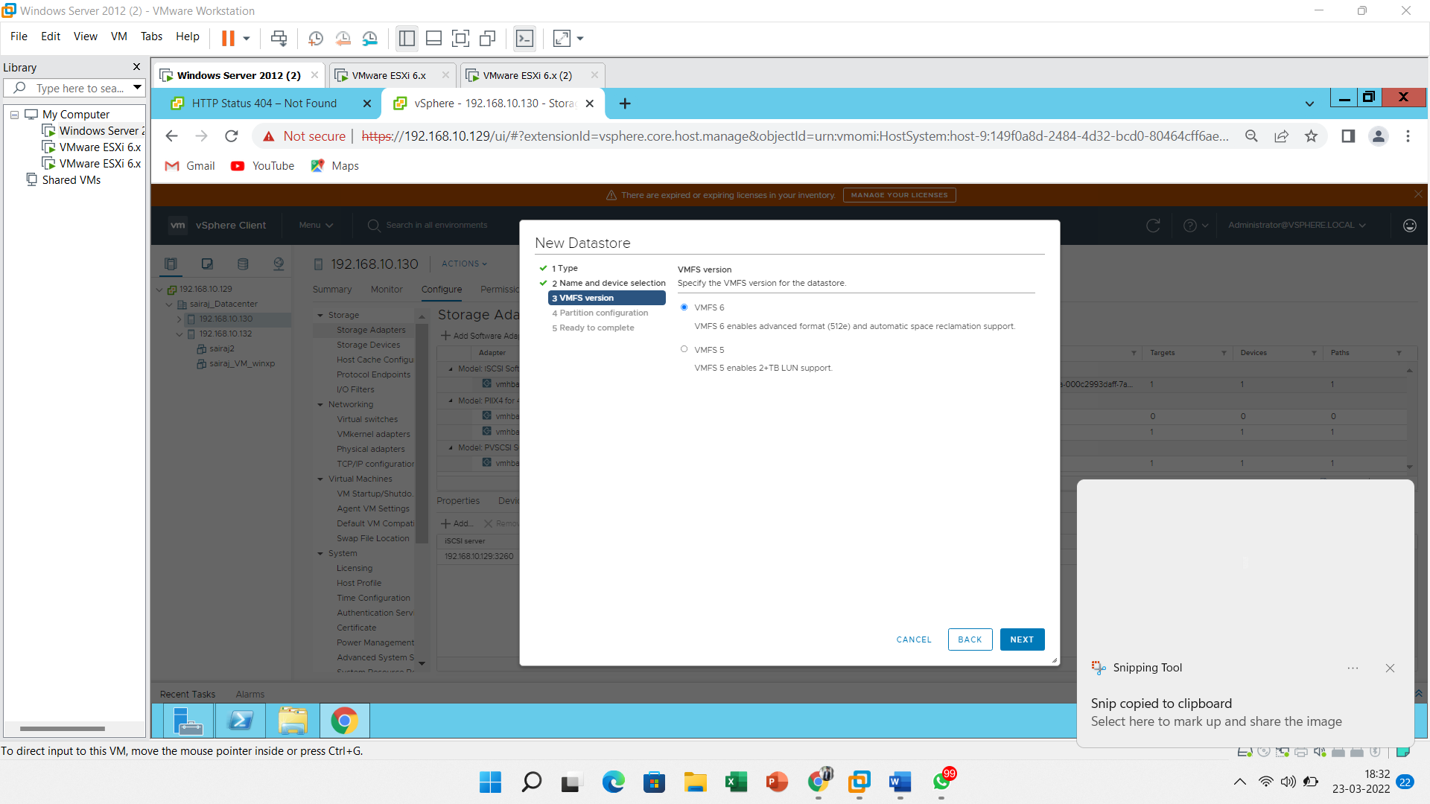

Click on **Next**.

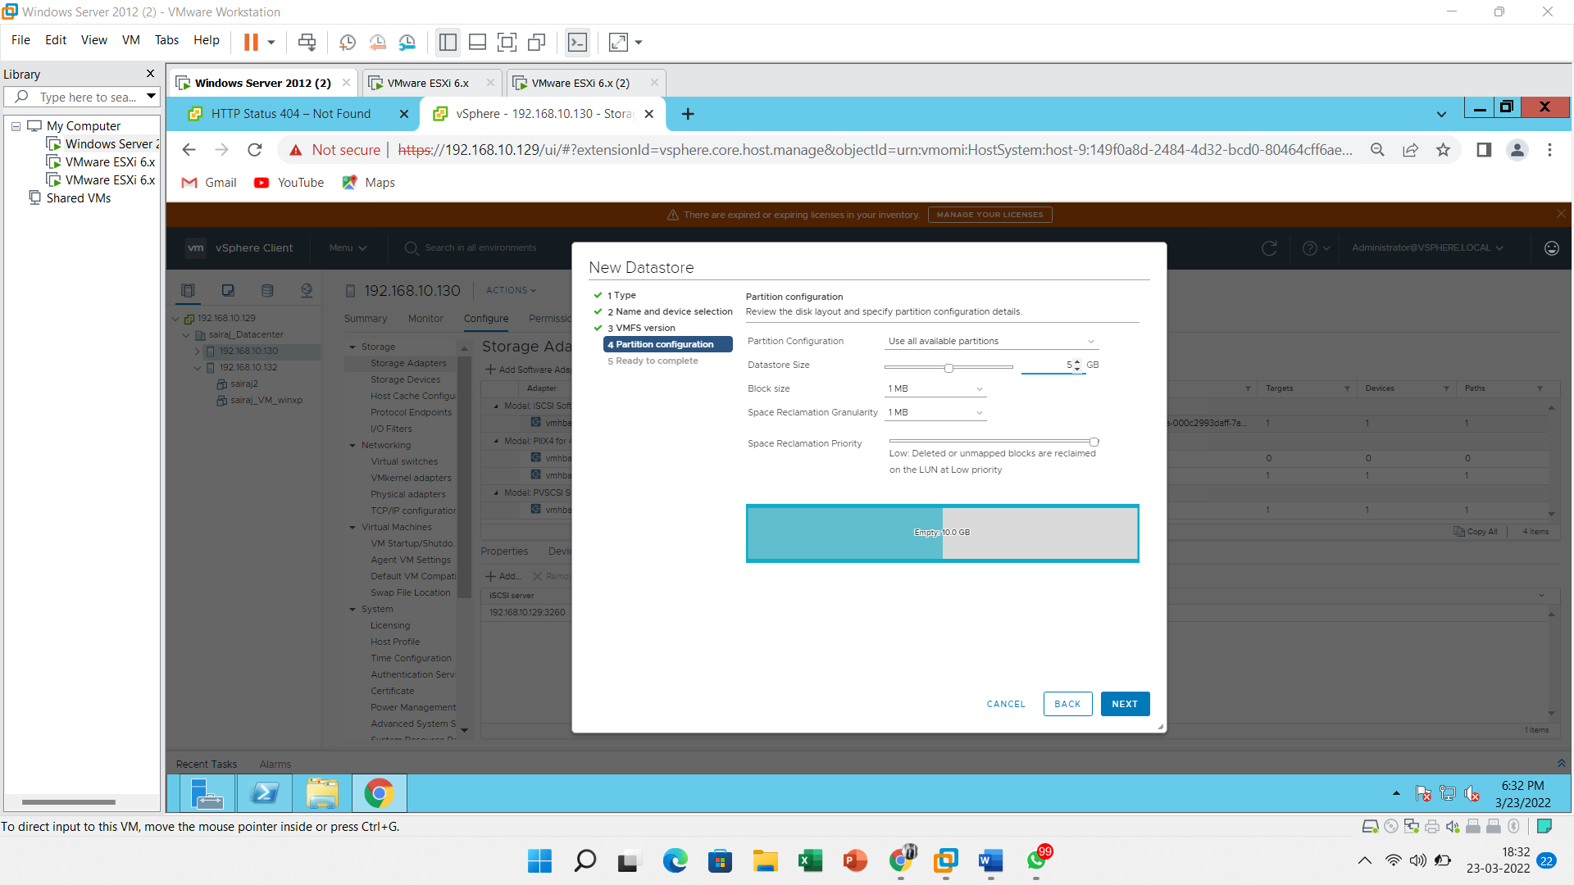

Click on the **Finish**

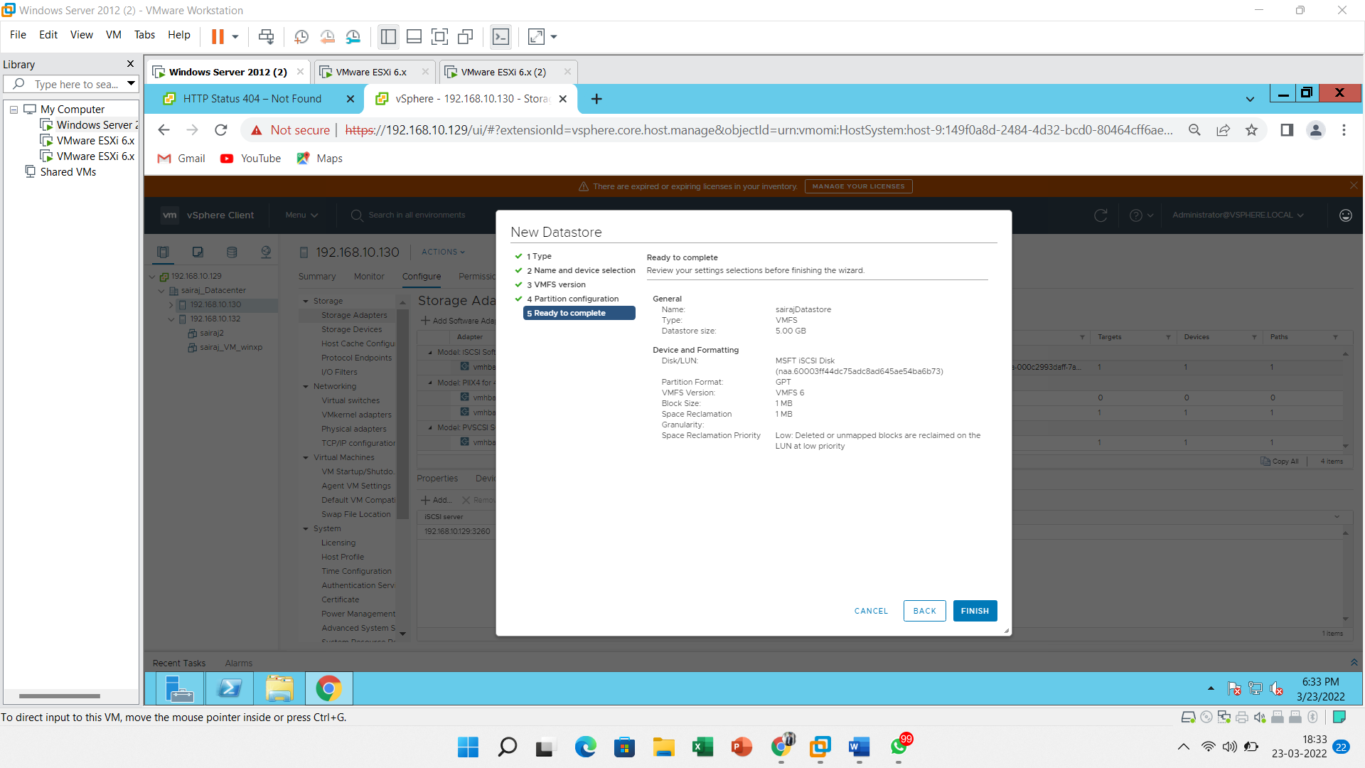

Here you can see **iSCSI storage** has been **created into the ESXi host**.

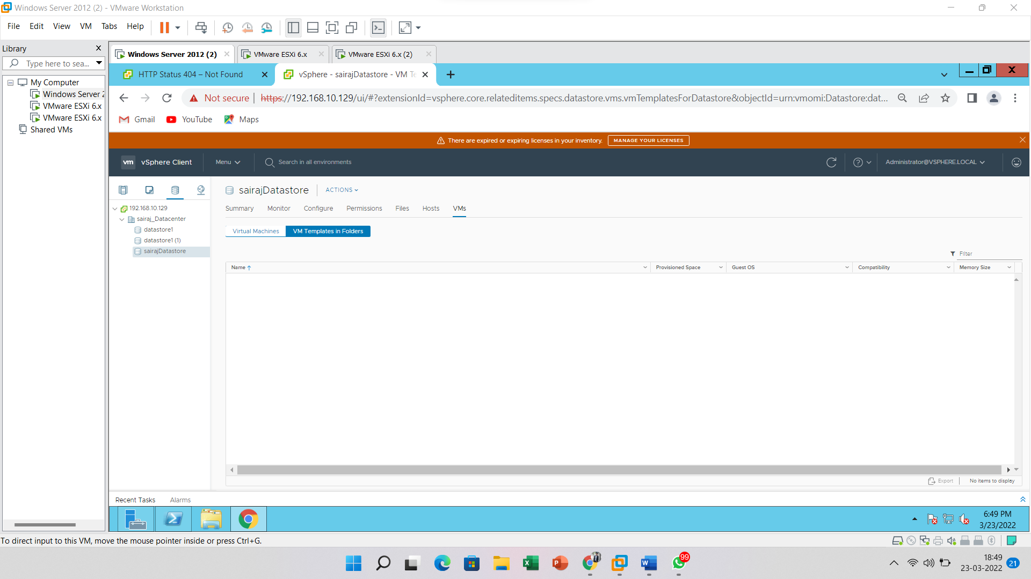

1. **Create a one user account of VMware ESXi server using vSphere WebClient Application.**

Login into vSphere server from Web Client application.

Click on the vSphere Client like below image

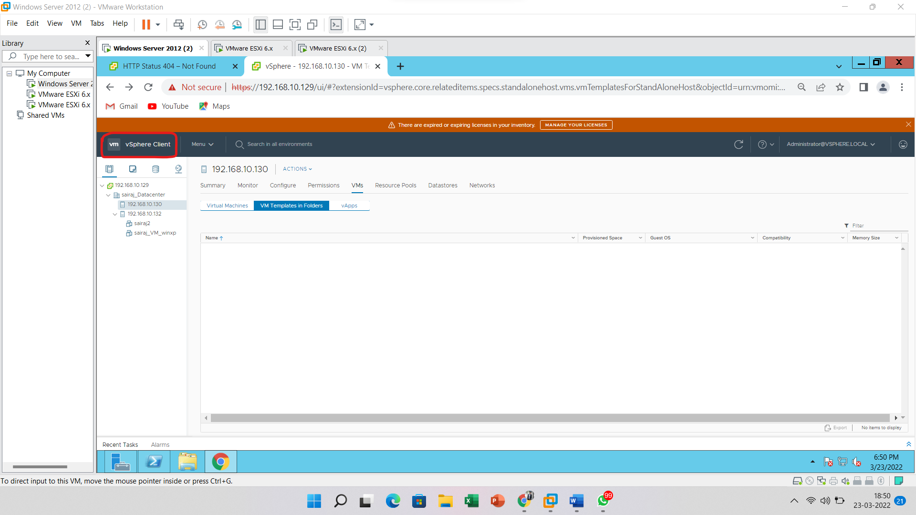

Go to “**Home**” and click on the “**Administration**” tab

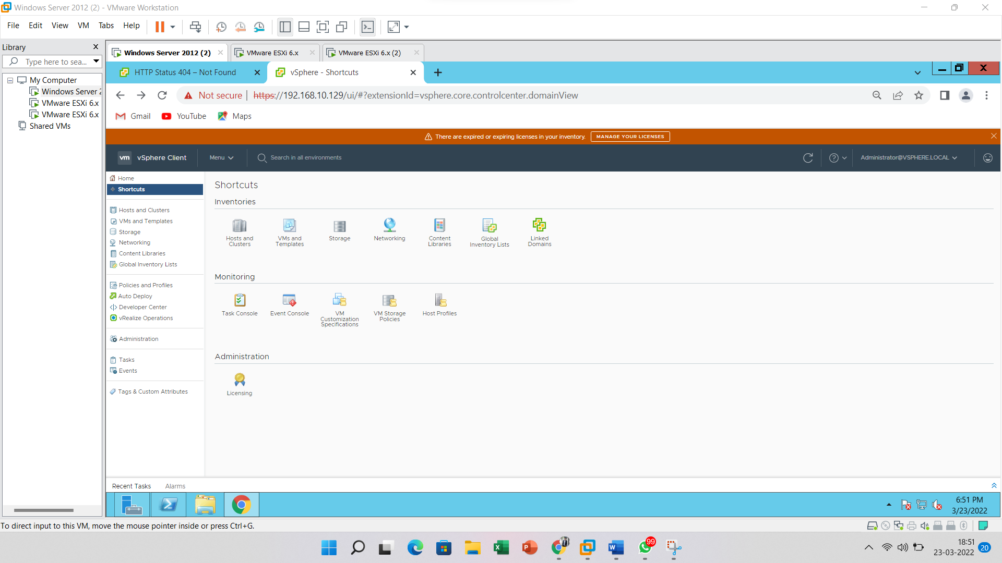

Go to the “**User and Groups**” tab select domain as **vsphere.local** and click on **add** button.

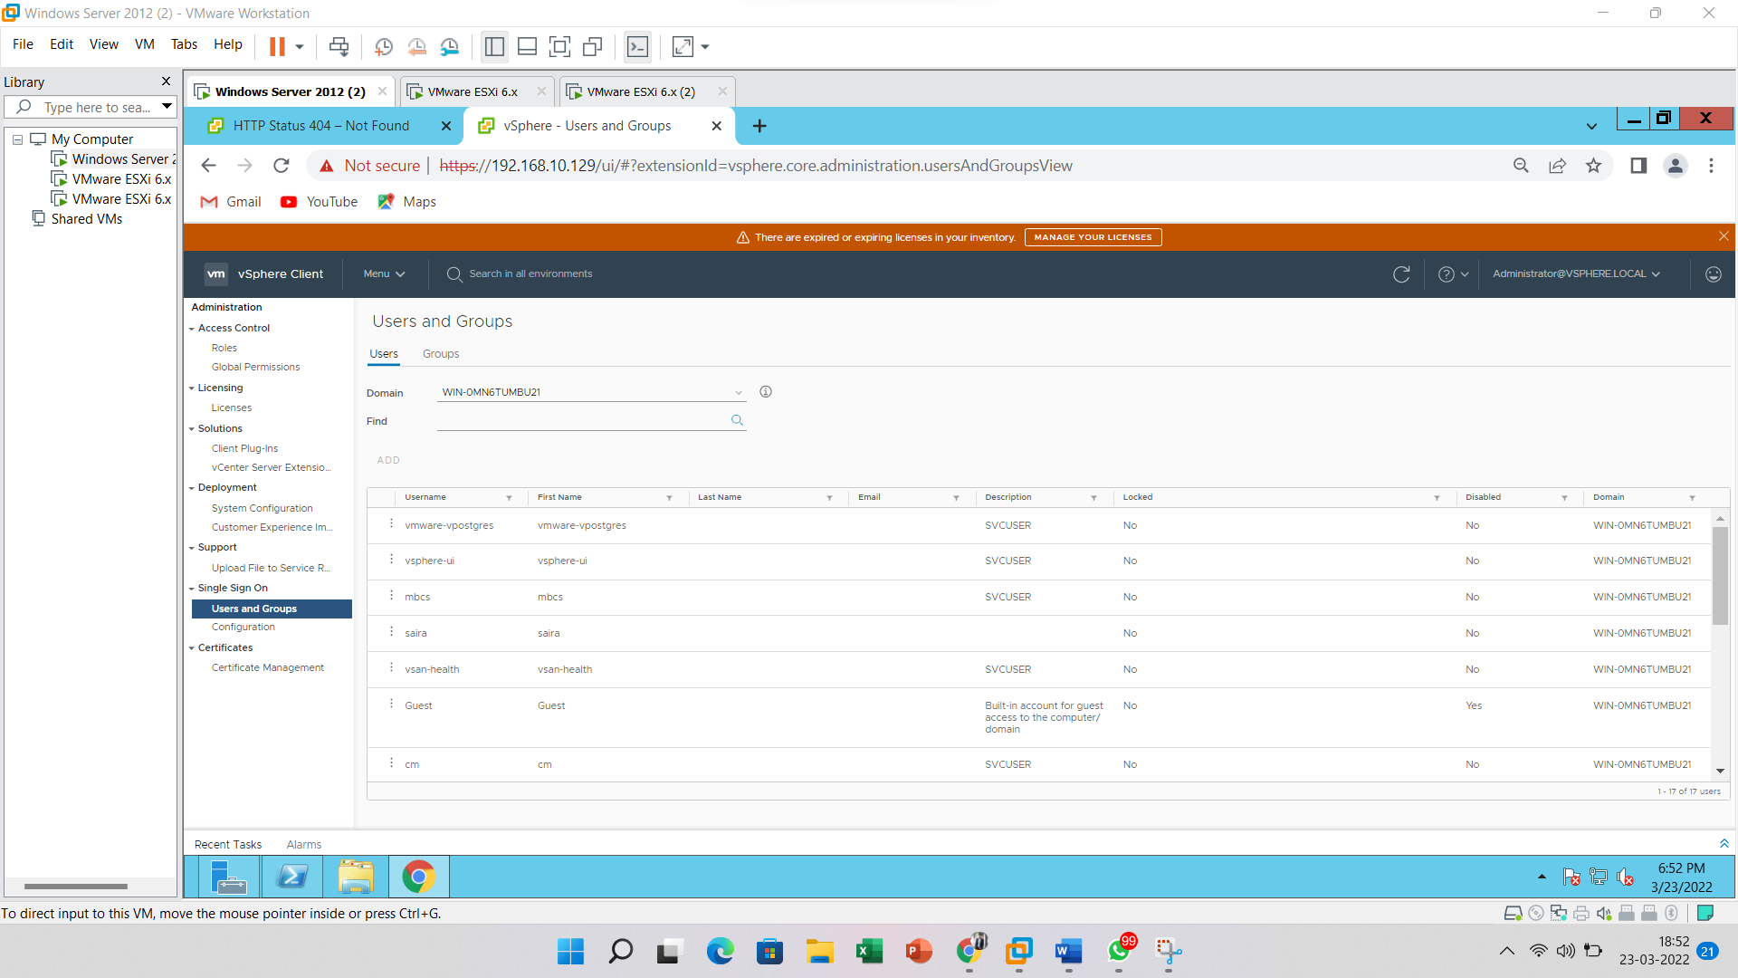

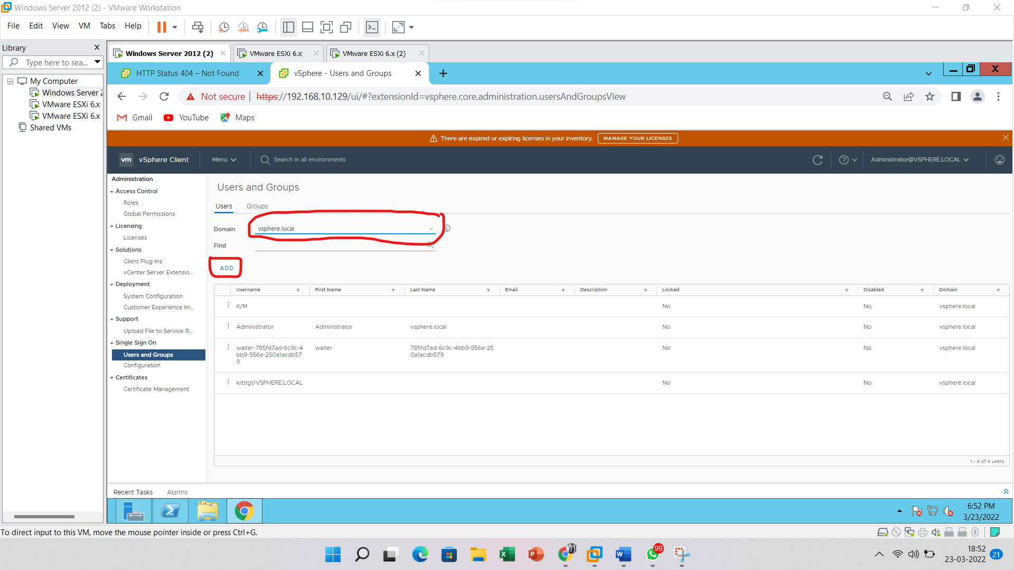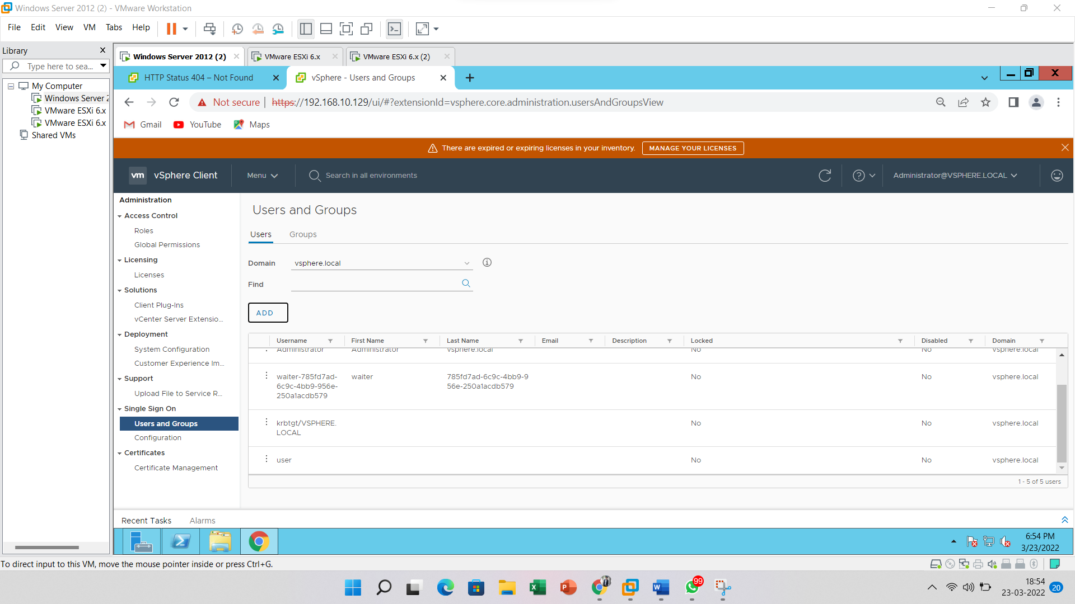

Now it's required to give permission to the newly created user

Go to “Global Permissions” and click on add button

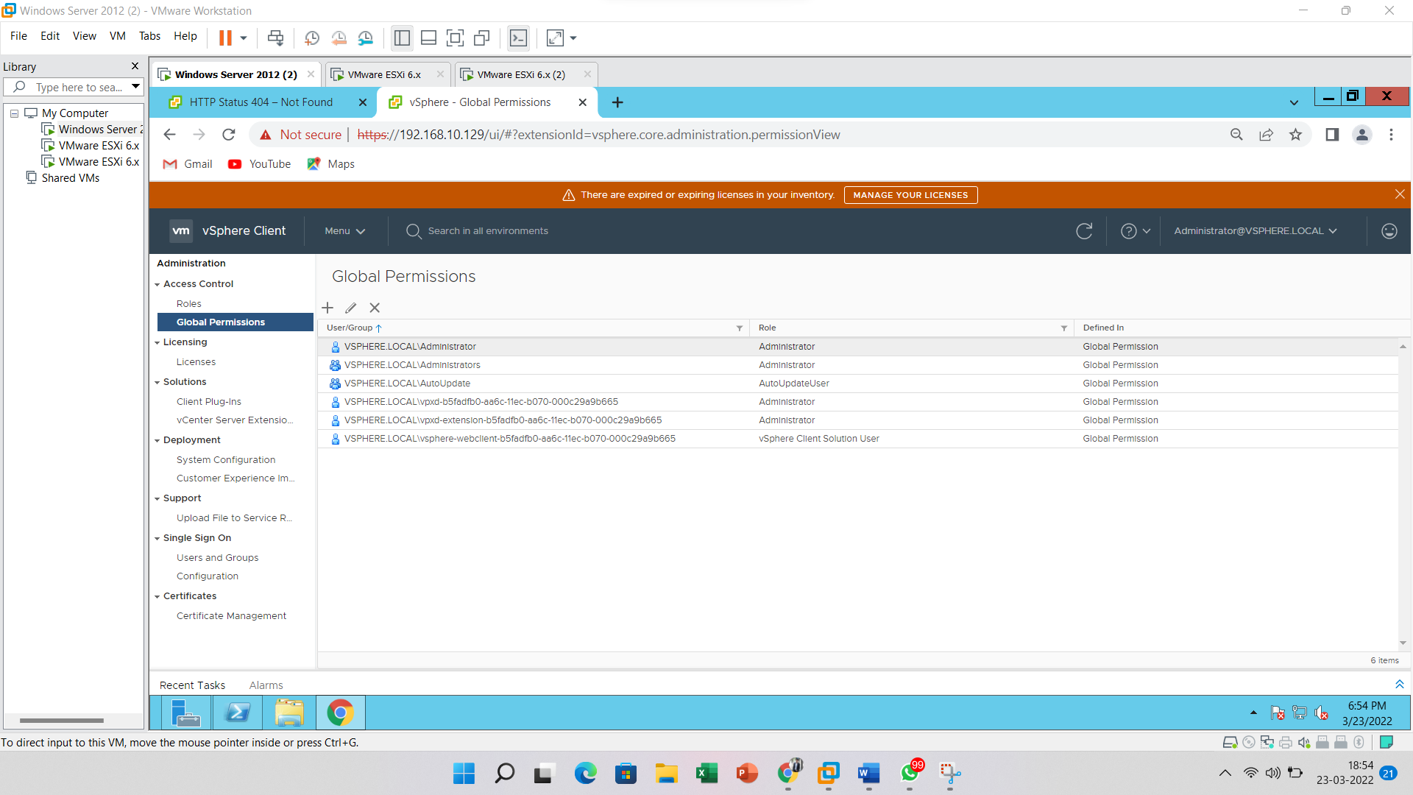

Add User details like Username & Password and Click on the **ADD** button

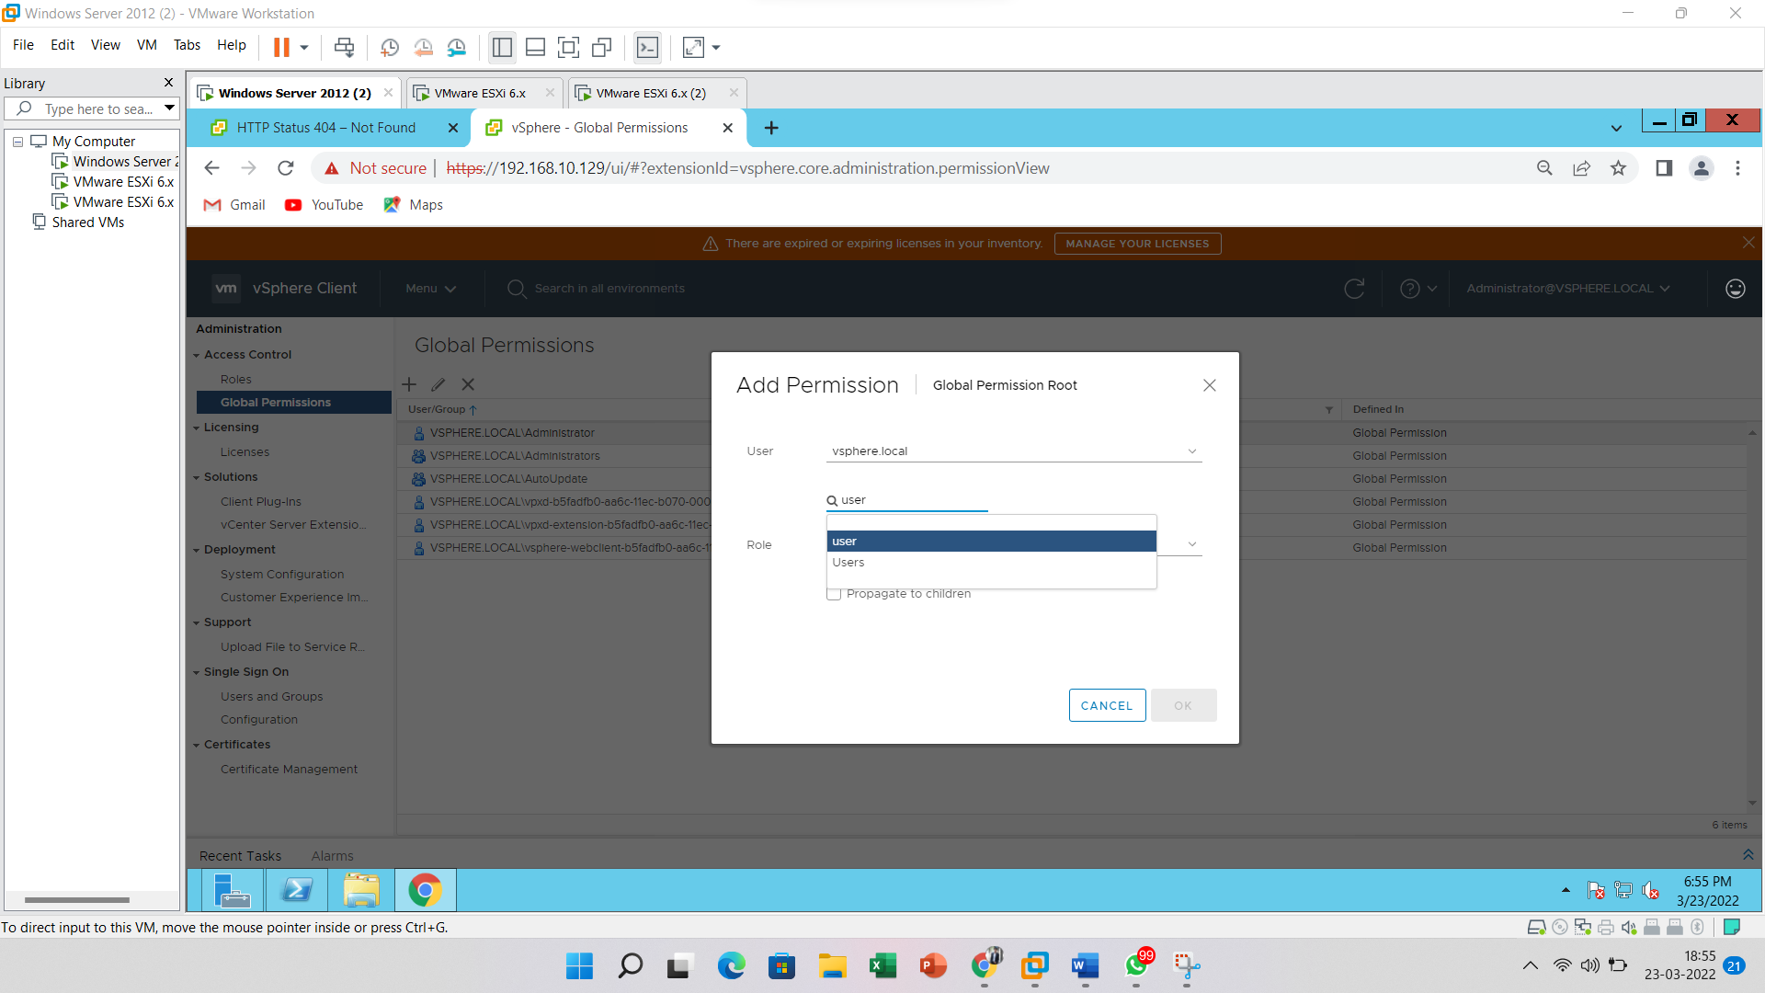

Select the user and click on the “**OK**” button. Choose a **role** for the user and click on the **OK** button

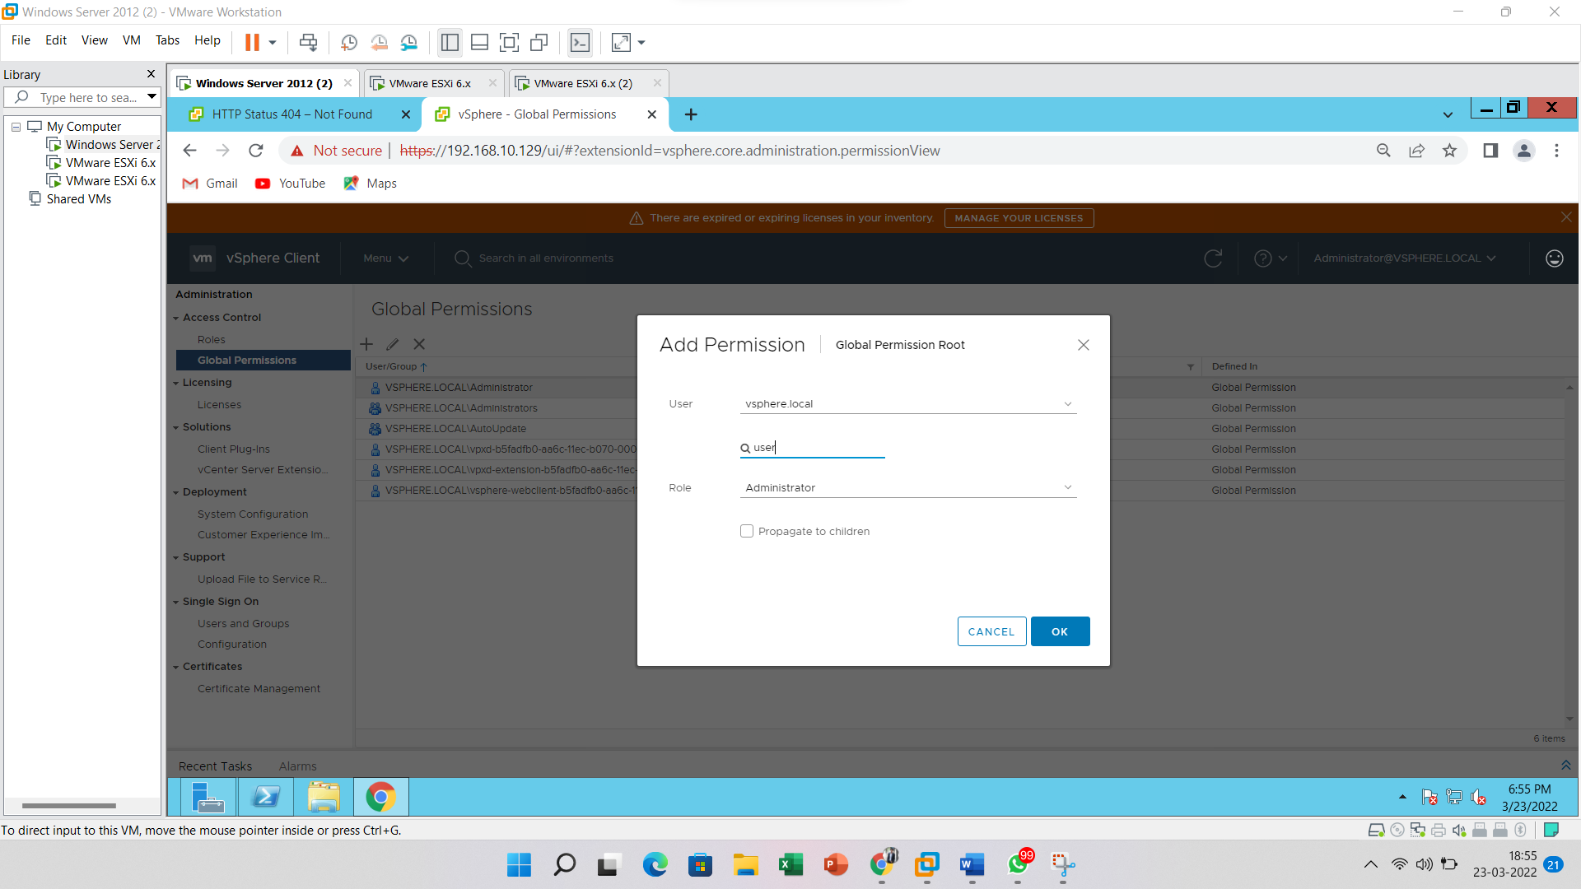

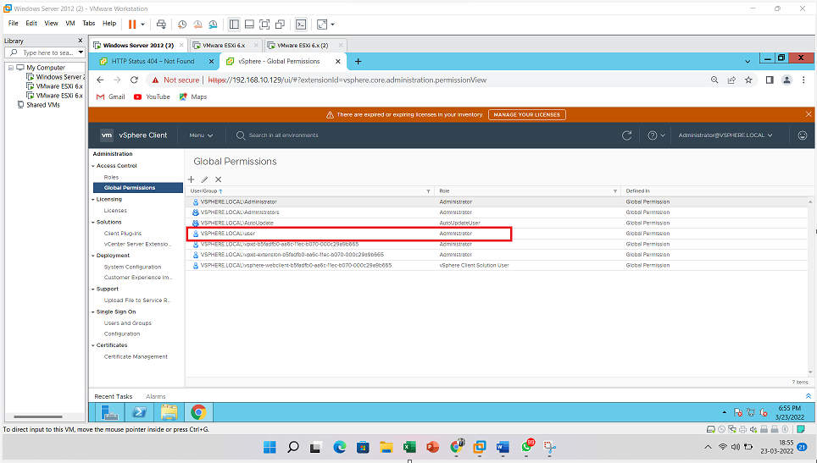

Now power-on of the virtual machine

Here you can see virtual machine has been started

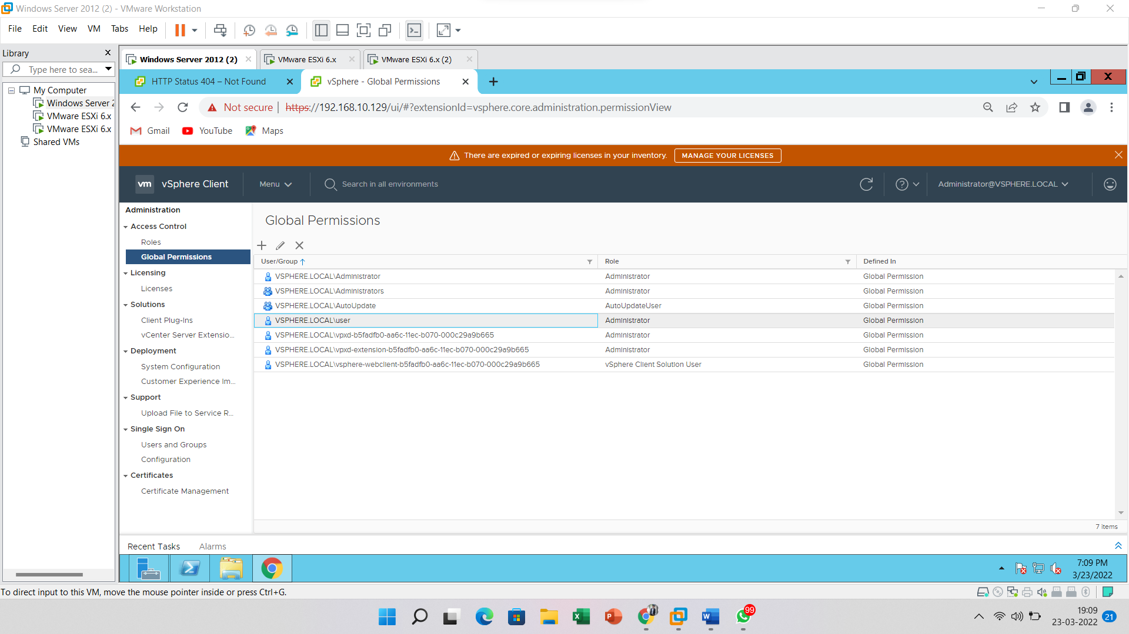

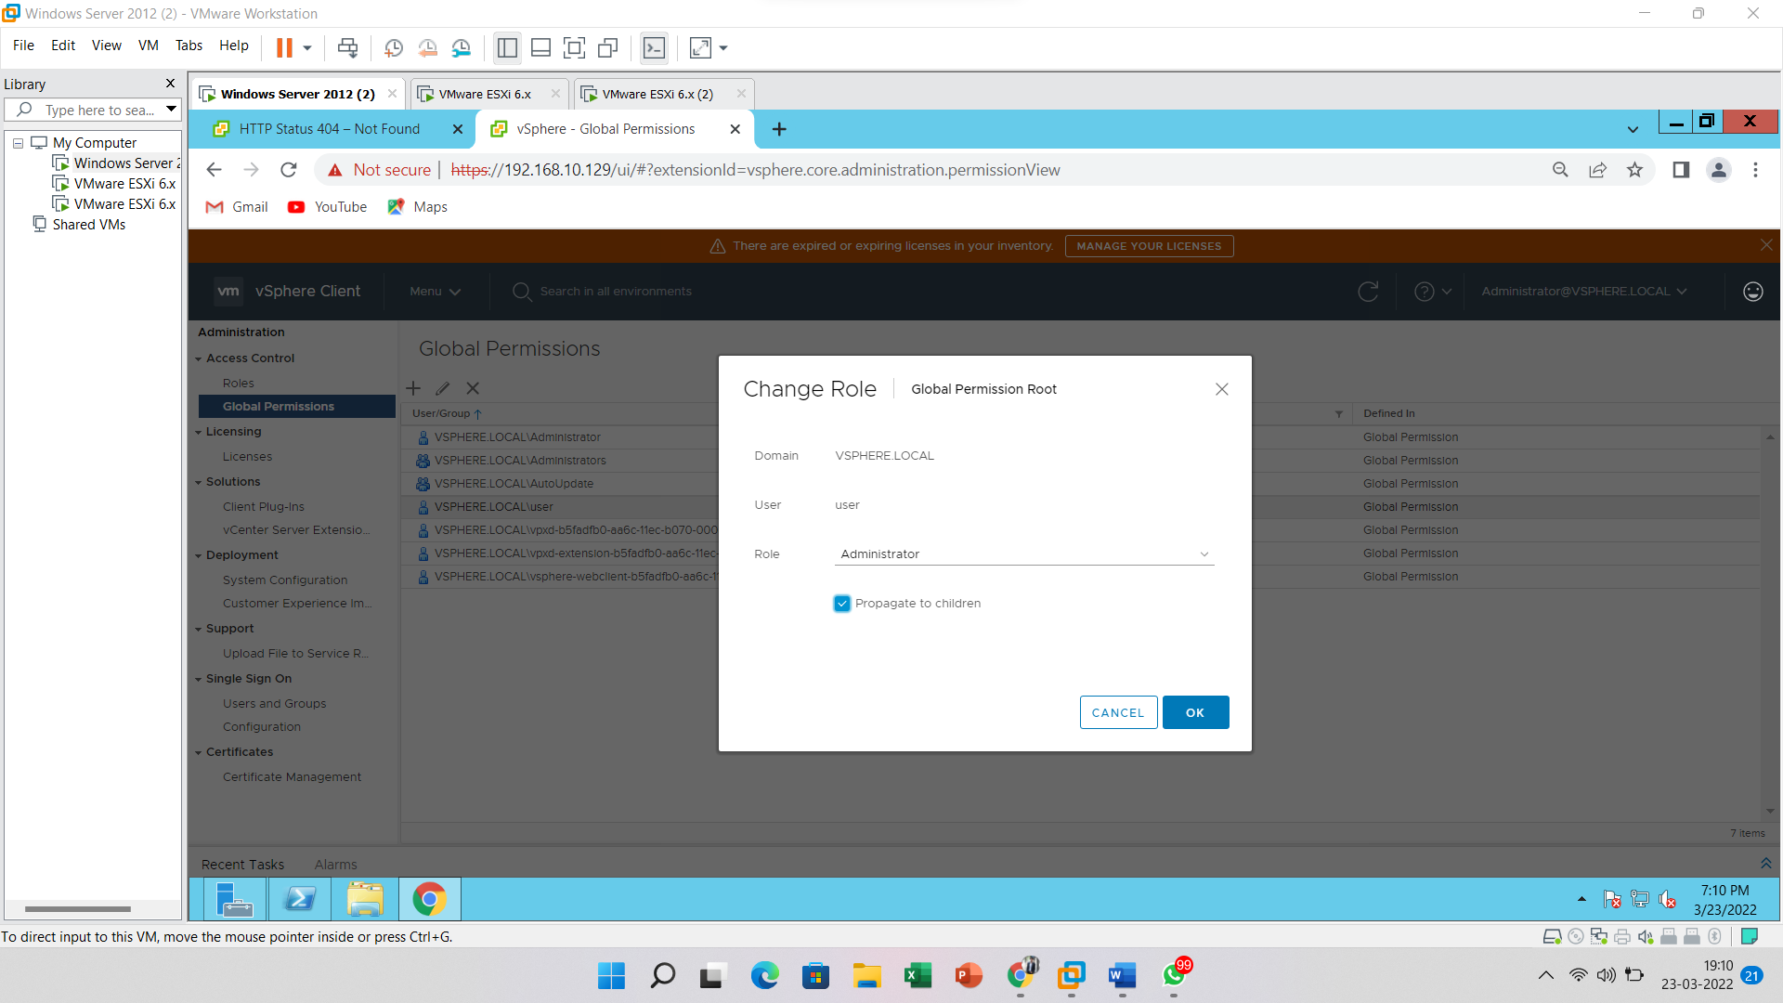

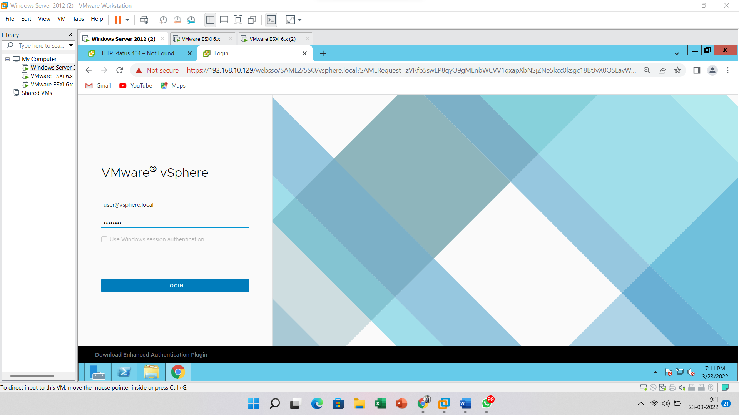

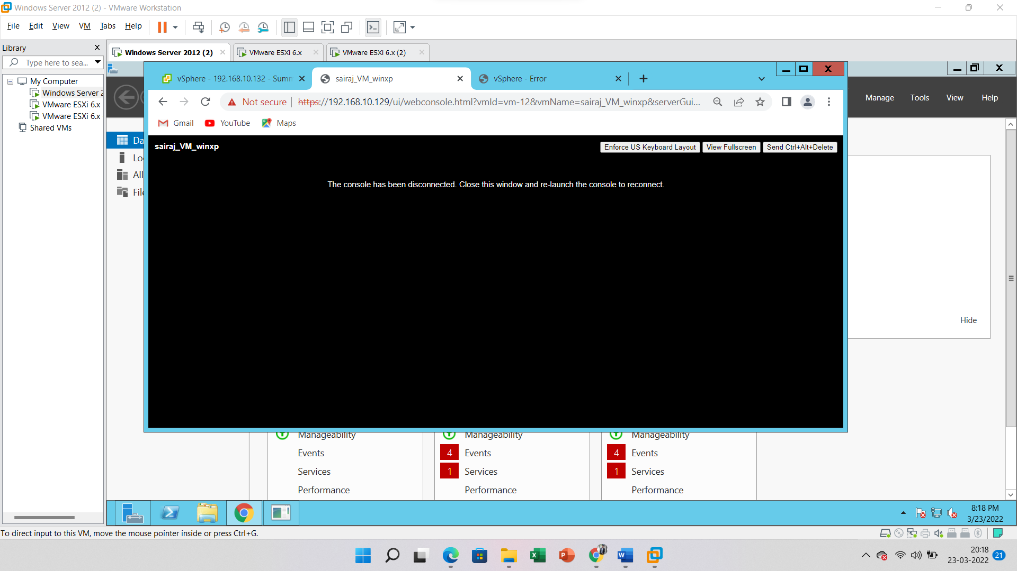

**4C**

1. **Prevent Users from Spying on Remote Console Sessions.**

Login into vSphere server from Web Client application.

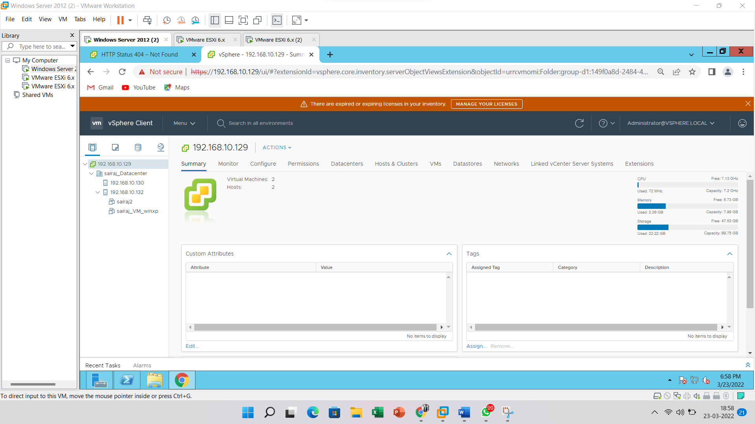

Select the **virtual machine** template and click on the **action** button.

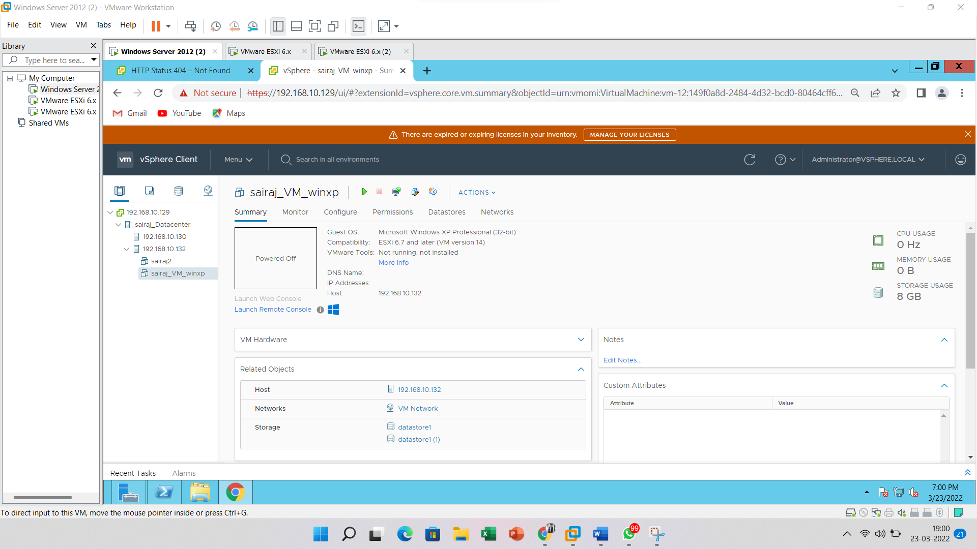

Click on the **Edit Settings** option.

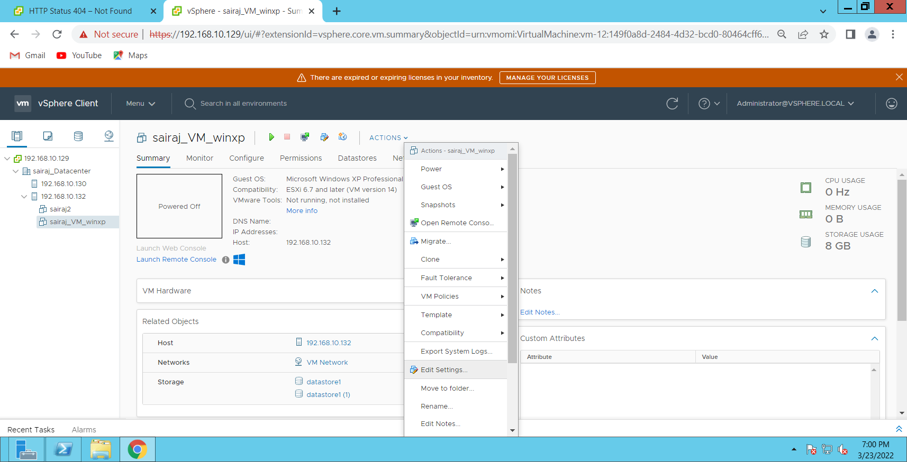

Click on **VM Options**, then go to **advanced**

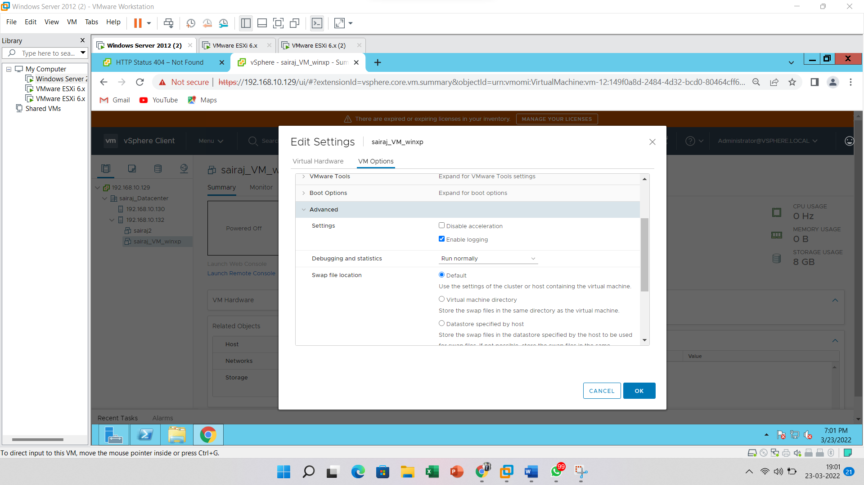

Click on **edit configurations**.

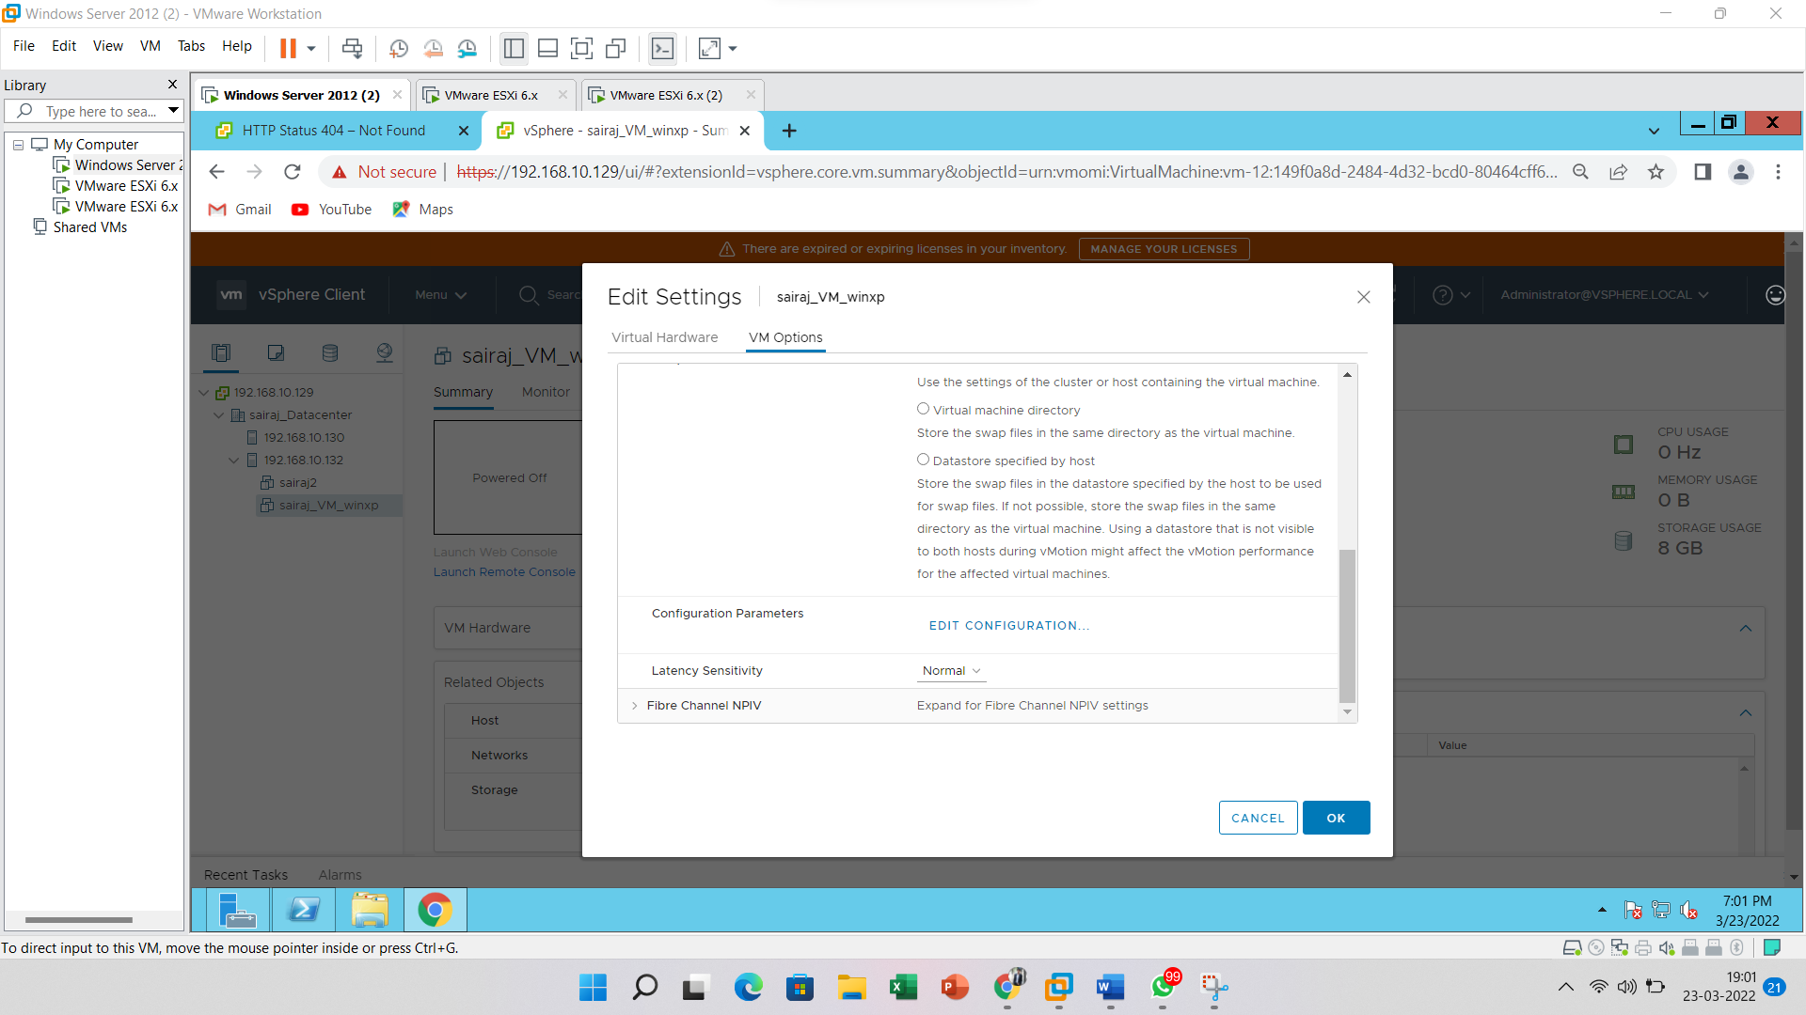

Click on the “**Add Configuration Params**” button and enter below details and **no of connections** you required and then click on the “**OK**” button. Add row with Name as **RemoteDisplay.MaxConnections** = 1

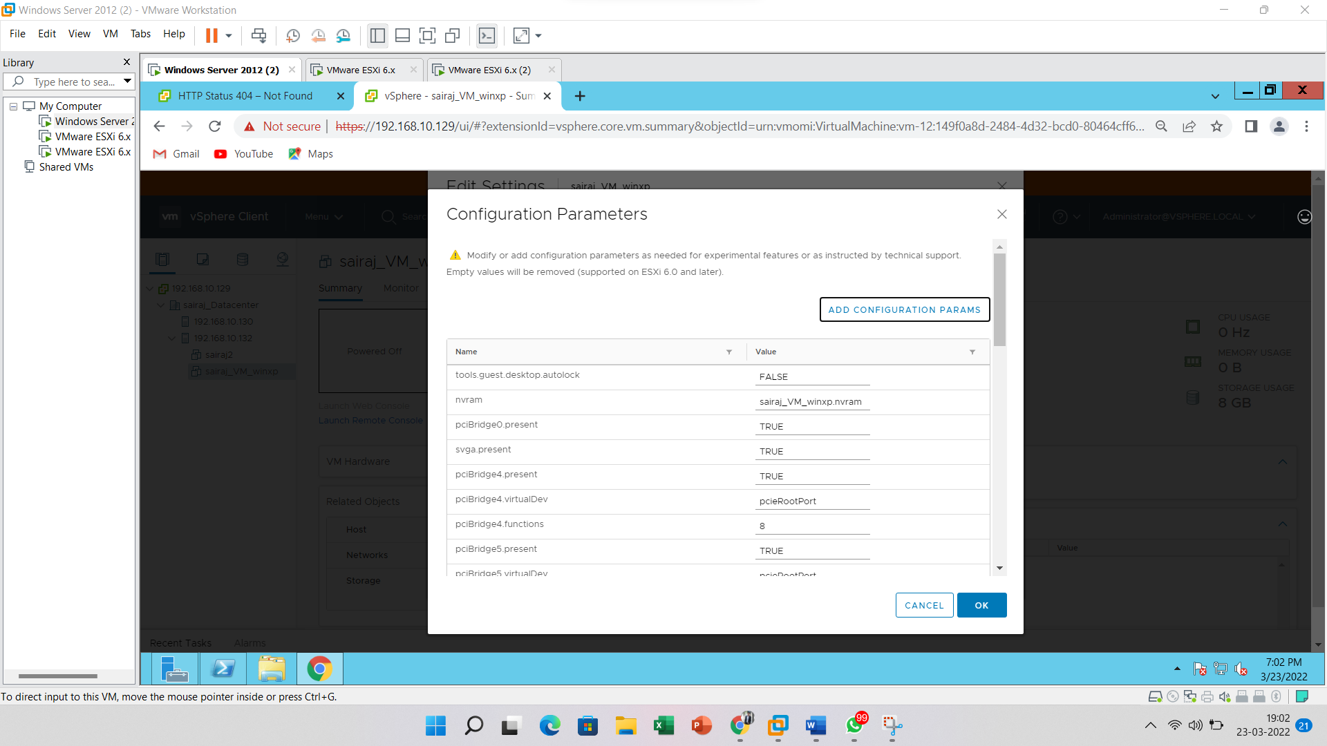

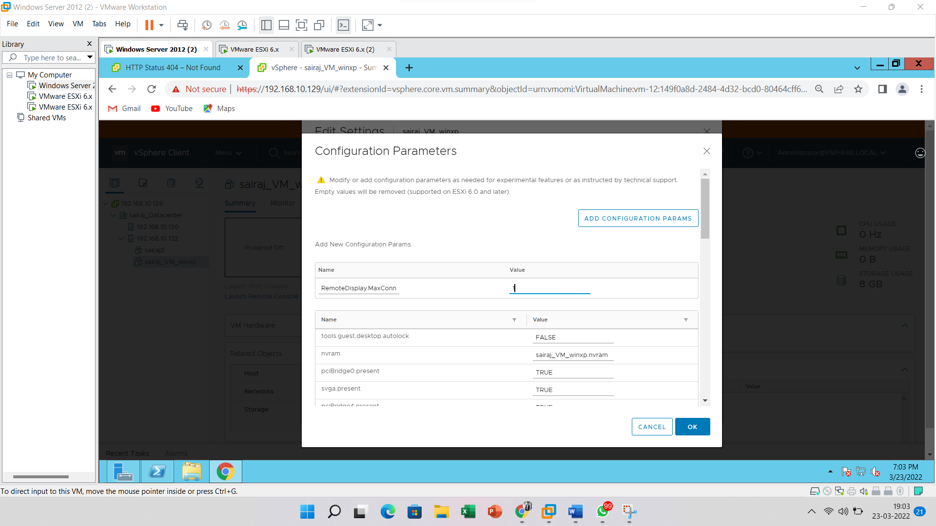

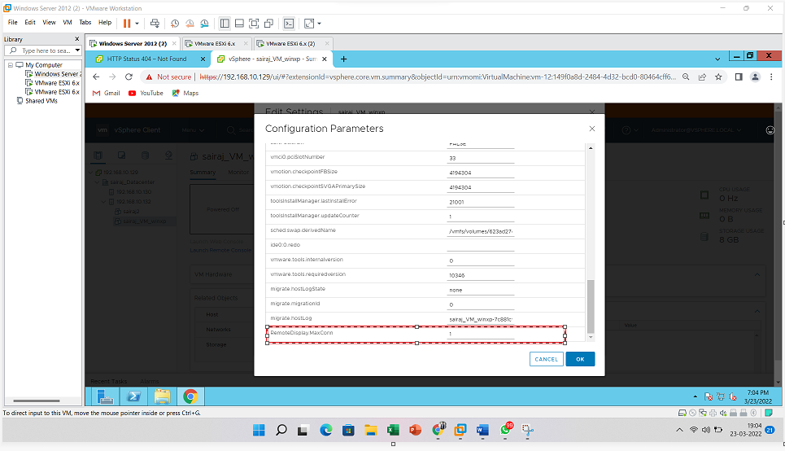

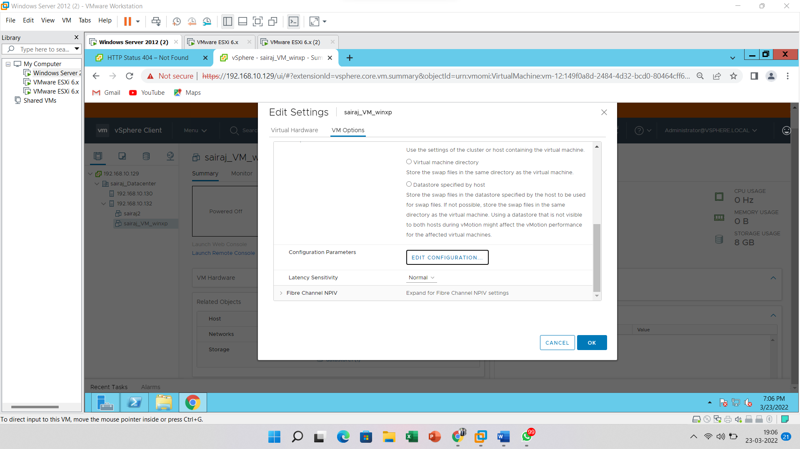

Now power-on of the virtual machine

Here you can see virtual machine has been started



